CHAPTER
UNIT – V

Unit Objectives:

- To study about cloud applications in different industries
- To learn about performance related advanced topics in Cloud Computing

Cloud Applications

Cloud computing has gained huge popularity in industry due to its ability to host applications for which the services can be delivered to consumers rapidly at minimal cost. This chapter discusses some application case studies, detailing their architecture and how they leveraged various cloud technologies. Applications from a range of domains, from scientific to engineering, gaming, and social networking, are considered.

Scientific applications

Scientific applications are a sector that is increasingly using cloud computing systems and technolo-gies. The immediate benefit seen by researchers and academics is the potentially infinite availability of computing resources and storage at sustainable prices compared to a complete in-house deployment. Cloud computing systems meet the needs of different types of applications in the scientific domain: high-performance computing (HPC) applications, high-throughput computing (HTC) applications, and data-intensive applications. The opportunity to use cloud resources is even more appealing because minimal changes need to be made to existing applications in order to leverage cloud resources.

The most relevant option is IaaS solutions, which offer the optimal environment for running bag-of-tasks applications and workflows. Virtual machine instances are opportunely customized to host the required software stack for running such applications and coordinated together with distrib-uted computing middleware capable of interacting with cloud-based infrastructures. PaaS solutions have been considered as well. They allow scientists to explore new programming models for tack-ling computationally challenging problems. Applications have been redesigned and implemented on top of cloud programming application models and platforms to leverage their unique capabilities. For instance, the MapReduce programming model provides scientists with a very simple and effec-tive model for building applications that need to process large datasets. Therefore it has been widely used to develop data-intensive scientific applications. Problems that require a higher degree of flexibility in terms of structuring of their computation model can leverage platforms such as Aneka, which supports MapReduce and other programming models. We now discuss some interest-ing case studies in which Aneka has been used.

Healthcare: ECG analysis in the cloud

Healthcare is a domain in which computer technology has found several and diverse applications:

from supporting the business functions to assisting scientists in developing solutions to cure diseases.

An important application is the use of cloud technologies to support doctors in providing more effective diagnostic processes. In particular, here we discuss electrocardiogram (ECG) data analysis on the cloud [160].

The capillary development of Internet connectivity and its accessibility from any device at any time has made cloud technologies an attractive option for developing health-monitoring systems. ECG data analysis and monitoring constitute a case that naturally fits into this scenario. ECG is the electrical manifestation of the contractile activity of the heart’s myocardium. This activity produces a specific waveform that is repeated over time and that represents the heartbeat. The analysis of the shape of the ECG waveform is used to identify arrhythmias and is the most common way to detect heart disease. Cloud computing technologies allow the remote monitoring of a patient’s heartbeat data, data analysis in minimal time, and the notification of first-aid personnel and doctors should these data reveal potentially dangerous conditions. This way a patient at risk can be constantly monitored without going to a hospital for ECG analysis. At the same time, doctors and first-aid per-sonnel can instantly be notified of cases that require their attention.

An illustration of the infrastructure and model for supporting remote ECG monitoring is shown in Figure 10.1. Wearable computing devices equipped with ECG sensors constantly monitor the patient’s heartbeat. Such information is transmitted to the patient’s mobile device, which will even-tually forward it to the cloud-hosted Web service for analysis. The Web service forms the front-end of a platform that is entirely hosted in the cloud and that leverages the three layers of the cloud computing stack: SaaS, PaaS, and IaaS. The Web service constitute the SaaS application that will store ECG data in the Amazon S3 service and issue a processing request to the scalable cloud plat-form. The runtime platform is composed of a dynamically sizable number of instances running the workflow engine and Aneka. The number of workflow engine instances is controlled according to the number of requests in the queue of each instance, while Aneka controls the number of EC2 instances used to execute the single tasks defined by the workflow engine for a single ECG proces-sing job. Each of these jobs consists of a set of operations involving the extraction of the waveform from the heartbeat data and the comparison of the waveform with a reference waveform to detect anomalies. If anomalies are found, doctors and first-aid personnel can be notified to act on a specific patient.

Even though remote ECG monitoring does not necessarily require cloud technologies, cloud computing introduces opportunities that would be otherwise hardly achievable. The first advantage is the elasticity of the cloud infrastructure that can grow and shrink according to the requests served. As a result, doctors and hospitals do not have to invest in large computing infrastructures designed after capacity planning, thus making more effective use of budgets. The second advantage is ubiquity. Cloud computing technologies have now become easily accessible and promise to deliver systems with minimum or no downtime. Computing systems hosted in the cloud are acces-sible from any Internet device through simple interfaces (such as SOAP and REST-based Web ser-vices). This makes these systems not only ubiquitous, but they can also be easily integrated with other systems maintained on the hospital’s premises. Finally, cost savings constitute another reason for the use of cloud technology in healthcare. Cloud services are priced on a pay-per-use basis and with volume prices for large numbers of service requests. These two models provide a set of flexi-ble options that can be used to price the service, thus actually charging costs based on effective use rather than capital costs.
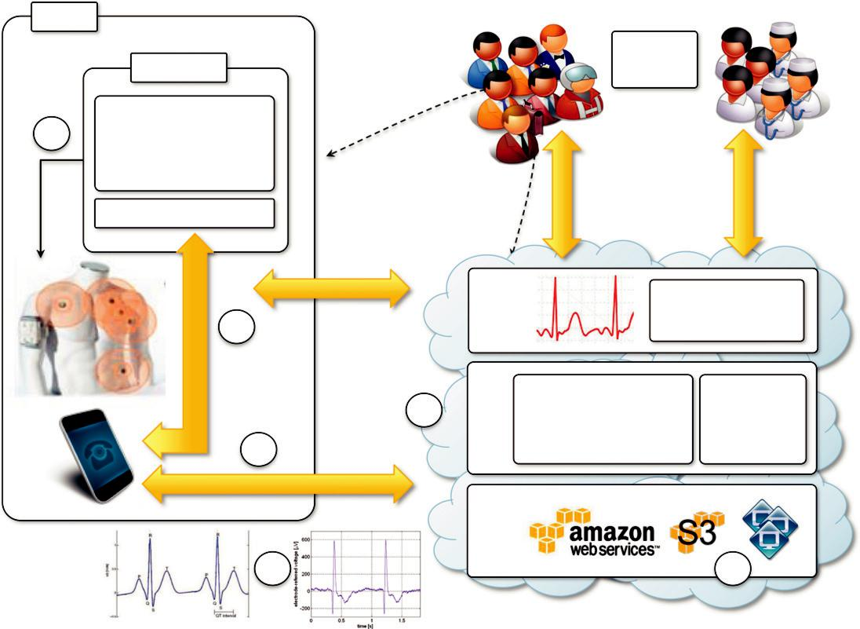

User

ECG Sensor

Embedded Bluetooth
₁ Enabled

Data Communication &

Processor Module

ECG Sensor Module

connectivity | User Requests
connectivity | 2
Bluetooth | 4
 | 3

Wireless / Mobile 3G Network

6

FIGURE 10.1

An online health monitoring system hosted in the cloud.

 | Large
 | Number
 | User Requests | User Requests
SaaS | ECG Data Analysis
 |  | as a Service
PaaS | Dynamically Scalable
PaaS | Runtime | Security
 | (QoS-based scaling of | Runtime
 | computing resources)
IaaS
 |  | 5

Biology: protein structure prediction

Applications in biology often require high computing capabilities and often operate on large data-sets that cause extensive I/O operations. Because of these requirements, biology applications have often made extensive use of supercomputing and cluster computing infrastructures. Similar capabil-ities can be leveraged on demand using cloud computing technologies in a more dynamic fashion, thus opening new opportunities for bioinformatics applications.

Protein structure prediction is a computationally intensive task that is fundamental to different types of research in the life sciences. Among these is the design of new drugs for the treatment of diseases. The geometric structure of a protein cannot be directly inferred from the sequence of genes that compose its structure, but it is the result of complex computations aimed at identifying the structure that minimizes the required energy. This task requires the investigation of a space with a massive number of states, consequently creating a large number of computations for each of these states. The computational power required for protein structure prediction can now be acquired on demand, without owning a cluster or navigating the bureaucracy to get access to

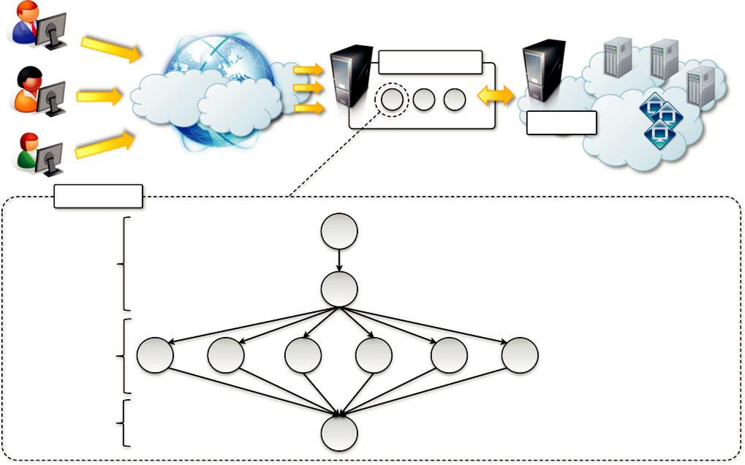

 |  |  |  |  | Jeeva Portal
 |  |  |  |  |  |  | Aneka
Task Graph
 |  |  |  | A |  |  | A : BLAST
Initial Phase |  |  |  |  |  |  | B : Create Data Vector
 |  |  |  | B |  |  | C : HH Classifier
 |  |  |  |  |  |  | D : SS Classifier
 |  |  |  |  |  |  | E : TT Classifier
Classification | C | D | E | F | G | H | F : HS Classifier
 |  |  |  |  |  |  | G : ST Classifier
Phase
Phase |  |  |  |  |  |  | H : TH Classifier
Final Phase |  |  |  | I |  |  | I : Predict Final Secondary
Final Phase |  |  |  | I |  |  | Structure

FIGURE 10.2

Architecture and overview of the Jeeva Portal.

parallel and distributed computing facilities. Cloud computing grants access to such capacity on a pay-per-use basis.

One project that investigates the use of cloud technologies for protein structure prediction is Jeeva [161]—an integrated Web portal that enables scientists to offload the prediction task to a computing cloud based on Aneka (see Figure 10.2). The prediction task uses machine learning tech-niques (support vector machines) for determining the secondary structure of proteins. These techni-ques translate the problem into one of pattern recognition, where a sequence has to be classified into one of three possible classes (E, H, and C). A popular implementation based on support vector machines divides the pattern recognition problem into three phases: initialization, classification, and a final phase. Even though these three phases have to be executed in sequence, it is possible to take advantage of parallel execution in the classification phase, where multiple classifiers are exe-cuted concurrently. This creates the opportunity to sensibly reduce the computational time of the prediction. The prediction algorithm is then translated into a task graph that is submitted to Aneka. Once the task is completed, the middleware makes the results available for visualization through the portal.

The advantage of using cloud technologies (i.e., Aneka as scalable cloud middleware) versus conventional grid infrastructures is the capability to leverage a scalable computing infrastructure that can be grown and shrunk on demand. This concept is distinctive of cloud technologies and constitutes a strategic advantage when applications are offered and delivered as a service.
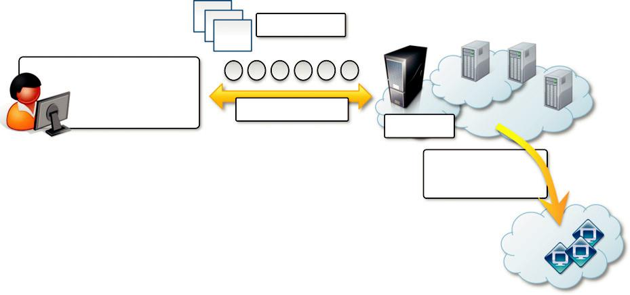

Datasets

Cloud-CoXCS

(Task orchestrator)
CoXCS Tasks
Aneka

Elastic Sizing

(EC2,…, )

FIGURE 10.3

Cloud-CoXCS: An environment for microarray data processing on the cloud.

Biology: gene expression data analysis for cancer diagnosis

Gene expression profiling is the measurement of the expression levels of thousands of genes at once. It is used to understand the biological processes that are triggered by medical treatment at a cellular level. Together with protein structure prediction, this activity is a fundamental component of drug design, since it allows scientists to identify the effects of a specific treatment.

Another important application of gene expression profiling is cancer diagnosis and treatment. Cancer is a disease characterized by uncontrolled cell growth and proliferation. This behavior occurs because genes regulating the cell growth mutate. This means that all the cancerous cells contain mutated genes. In this context, gene expression profiling is utilized to provide a more accu-rate classification of tumors. The classification of gene expression data samples into distinct classes is a challenging task. The dimensionality of typical gene expression datasets ranges from several thousands to over tens of thousands of genes. However, only small sample sizes are typically avail-able for analysis.

This problem is often approached with learning classifiers, which generate a population of condition-action rules that guide the classification process. Among these, the eXtended Classifier System (XCS) has been successfully utilized for classifying large datasets in the bioinformatics and computer science domains. However, the effectiveness of XCS, when confronted with high dimen-sional datasets (such as microarray gene expression data sets), has not been explored in detail. A variation of this algorithm, CoXCS [162], has proven to be effective in these conditions. CoXCS divides the entire search space into subdomains and employs the standard XCS algorithm in each of these subdomains. Such a process is computationally intensive but can be easily parallelized because the classifications problems on the subdomains can be solved concurrently. Cloud-CoXCS (see Figure 10.3) is a cloud-based implementation of CoXCS that leverages Aneka to solve the classification problems in parallel and compose their outcomes. The algorithm is controlled by strategies, which define the way the outcomes are composed together and whether the process needs to be iterated.

Because of the dynamic nature of XCS, the number of required compute resources to execute it can vary over time. Therefore, the use of scalable middleware such as Aneka offers a distinctive advantage.

Geoscience: satellite image processing

Geoscience applications collect, produce, and analyze massive amounts of geospatial and nonspatial data. As the technology progresses and our planet becomes more instrumented (i.e., through the deployment of sensors and satellites for monitoring), the volume of data that needs to be processed increases significantly. In particular, the geographic information system (GIS) is a major element of geoscience applications. GIS applications capture, store, manipulate, analyze, manage, and pres-ent all types of geographically referenced data. This type of information is now becoming increas-ingly relevant to a wide variety of application domains: from advanced farming to civil security and natural resources management. As a result, a considerable amount of geo-referenced data is ingested into computer systems for further processing and analysis. Cloud computing is an attrac-tive option for executing these demanding tasks and extracting meaningful information to support decision makers.

Satellite remote sensing generates hundreds of gigabytes of raw images that need to be further processed to become the basis of several different GIS products. This process requires both I/O and compute-intensive tasks. Large images need to be moved from a ground station’s local storage to compute facilities, where several transformations and corrections are applied. Cloud computing pro-vides the appropriate infrastructure to support such application scenarios. A cloud-based implemen-tation of such a workflow has been developed by the Department of Space, Government of India

The system shown in Figure 10.4 integrates several technologies across the entire computing stack. A SaaS application provides a collection of services for such tasks as geocode generation and data visualization. At the PaaS level, Aneka controls the importing of data into the virtualized infrastructure and the execution of image-processing tasks that produce the desired outcome from raw satellite images. The platform leverages a Xen private cloud and the Aneka technology to dynamically provision the required resources (i.e., grow or shrink) on demand.

The project demonstrates how cloud computing technologies can be effectively employed to off-load local computing facilities from excessive workloads and leverage more elastic computing infrastructures.

Business and consumer applications

The business and consumer sector is the one that probably benefits the most from cloud computing technologies. On one hand, the opportunity to transform capital costs into operational costs makes clouds an attractive option for all enterprises that are IT-centric. On the other hand, the sense of ubiquity that the cloud offers for accessing data and services makes it interesting for end users as well. Moreover, the elastic nature of cloud technologies does not require huge up-front investments, thus allowing new ideas to be quickly translated into products and services that can comfortably grow with the demand. The combination of all these elements has made cloud computing the
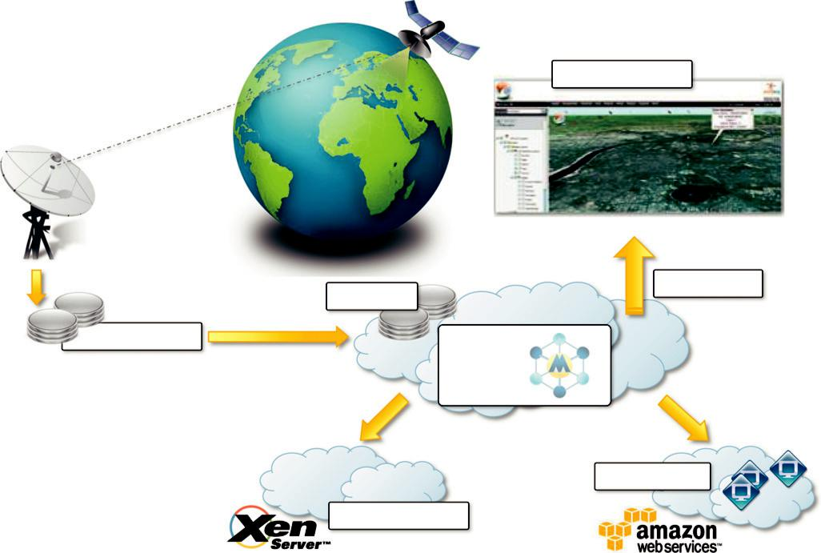

Portal (SaaS)

Archiving

Local Storage

Distribution

Aneka

Public Cloud

Private Cloud

FIGURE 10.4

A cloud environment for satellite data processing.

preferred technology for a wide range of applications, from CRM and ERP systems to productivity and social-networking applications.

CRM and ERP

Customer relationship management (CRM) and enterprise resource planning (ERP) applications are market segments that are flourishing in the cloud, with CRM applications the more mature of the two. Cloud CRM applications constitute a great opportunity for small enterprises and start-ups to have fully functional CRM software without large up-front costs and by paying subscriptions. Moreover, CRM is not an activity that requires specific needs, and it can be easily moved to the cloud. Such a characteristic, together with the possibility of having access to your business and cus-tomer data from everywhere and from any device, has fostered the spread of cloud CRM applica-tions. ERP solutions on the cloud are less mature and have to compete with well-established in-house solutions. ERP systems integrate several aspects of an enterprise: finance and accounting, human resources, manufacturing, supply chain management, project management, and CRM. Their goal is to provide a uniform view and access to all operations that need to be performed to sustain a complex organization. Because of the organizations that they target, the transition to cloud-based models is more difficult: he cost advantage over the long term might not be clear, and the switch to

the cloud could be difficult if organizations already have large ERP installations. For this reason cloud ERP solutions are less popular than CRM solutions at this time.

Salesforce.com

Salesforce.com is probably the most popular and developed CRM solution available today. As of today more than 100,000 customers have chosen Safesforce.com to implement their CRM solutions. The application provides customizable CRM solutions that can be integrated with additional fea-tures developed by third parties. Salesforce.com is based on the Force.com cloud development plat-form. This represents scalable and high-performance middleware executing all the operations of all Salesforce.com applications.

The architecture of the Force.com platform is shown in Figure 10.5. Initially designed to sup-port scalable CRM applications, the platform has evolved to support the entire life cycle of a wider range of cloud applications by implementing a flexible and scalable infrastructure. At the core of the platform resides its metadata architecture, which provides the system with flexibility and scal-ability. Rather than being built on top of specific components and tables, application core logic and business rules are saved as metadata into the Force.com store. Both application structure and
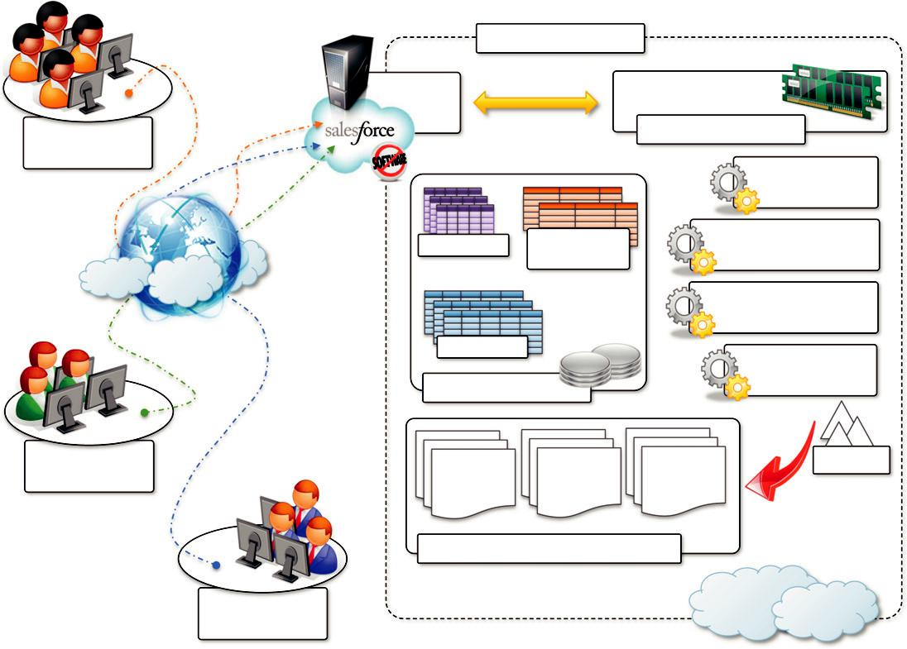

 | Force.com Platform
User-base 1: | Metadata Cache
Application 1
Bulk Processing

Engine

Pivot Tables | Metadata
 | Tables (UDD)

Multitenant-aware

Query Optimiser

Runtime Application

Generator

Data Tables
 |  |  |  | Full-text Search
 | Shared Database |  |  | Engine
User-base 2: | COMMON | TENANT- | OBJECTS | Indexes
Application 2 | COMMON | TENANT- | OBJECTS
Application 2 | APPLICATION | SPECIFIC | (TABLES)
 | SCREENS | SCREENS

Virtual Application Components

User-base 3:

Application 3

FIGURE 10.5

Salesforce.com and Force.com architecture.

application data are stored in the store. A runtime engine executes application logic by retrieving its metadata and then performing the operations on the data. Although running in isolated contain-ers, different applications logically share the same database structure, and the runtime engine exe-cutes all of them uniformly. A full-text search engine supports the runtime engine. This allows application users to have an effective user experience despite the large amounts of data that need to be crawled. The search engine maintains its indexing data in a separate store and is constantly updated by background processes triggered by user interaction.

Users can customize their application by leveraging the “native” Force.com application frame-work or by using programmatic APIs in the most popular programming languages. The application framework allows users to visually define either the data or the core structure of a Force.com appli-cation, while the programmatic APIs provide them with a more conventional way for developing applications that relies on Web services to interact with the platform. Customization of application processes and logic can also be implemented by developing scripts in APEX. This is a Java-like language that provides object-oriented and procedural capabilities for defining either scripts exe-cuted on demand or triggers. APEX also offers the capability of expressing searches and queries to have complete access to the data managed by the Force.com platform.

Microsoft dynamics CRM

Microsoft Dynamics CRM is the solution implemented by Microsoft for customer relationship man-agement. Dynamics CRM is available either for installation on the enterprise’s premises or as an online solution priced as a monthly per-user subscription.

The system is completely hosted in Microsoft’s datacenters across the world and offers to custo-mers a 99.9% SLA, with bonus credits if the system does not fulfill the agreement. Each CRM instance is deployed on a separate database, and the application provides users with facilities for marketing, sales, and advanced customer relationship management. Dynamics CRM Online features can be accessed either through a Web browser interface or programmatically by means of SOAP and RESTful Web services. This allows Dynamics CRM to be easily integrated with both other Microsoft products and line-of-business applications. Dynamics CRM can be extended by develop-ing plug-ins that allow implementing specific behaviors triggered on the occurrence of given events. Dynamics CRM can also leverage the capability of Windows Azure for the development and integration of new features.

NetSuite

NetSuite provides a collection of applications that help customers manage every aspect of the busi-ness enterprise. Its offering is divided into three major products: NetSuite Global ERP, NetSuite Global CRM1 , and NetSuite Global Ecommerce. Moreover, an all-in-one solution: NetSuite One World, integrates all three products together.

The services NetSuite delivers are powered by two large datacenters on the East and West coasts of the United States, connected by redundant links. This allows NetSuite to guarantee 99.5% uptime to its customers. Besides the prepackaged solutions, NetSuite also provides an infrastructure and a development environment for implementing customized applications. The NetSuite Business Operating System (NS-BOS) is a complete stack of technologies for building SaaS business applica-tions that leverage the capabilities of NetSuite products. On top of the SaaS infrastructure, the NetSuite Business Suite components offer accounting, ERP, CRM, and ecommerce capabilities.

An online development environment, SuiteFlex, allows integrating such capabilities into new Web applications, which are then packaged for distribution by SuiteBundler. The entire infrastructure is hosted in the NetSuite datacenters, which provide warranties regarding application uptime and availability.

Productivity

Productivity applications replicate in the cloud some of the most common tasks that we are used to performing on our desktop: from document storage to office automation and complete desktop environments hosted in the cloud.

Dropbox and iCloud

One of the core features of cloud computing is availability anywhere, at any time, and from any Internet-connected device. Therefore, document storage constitutes a natural application for such technology. Online storage solutions preceded cloud computing, but they never became popular. With the development of cloud technologies, online storage solutions have turned into SaaS appli-cations and become more usable as well as more advanced and accessible.

Perhaps the most popular solution for online document storage is Dropbox, an online applica-tion that allows users to synchronize any file across any platform and any device in a seamless manner (see Figure 10.6). Dropbox provides users with a free amount of storage that is accessible through the abstraction of a folder. Users can either access their Dropbox folder through a browser or by downloading and installing a Dropbox client, which provides access to the online storage by means of a special folder. All the modifications into this folder are silently synched so that changes are notified to all the local instances of the Dropbox folder across all the devices. The key
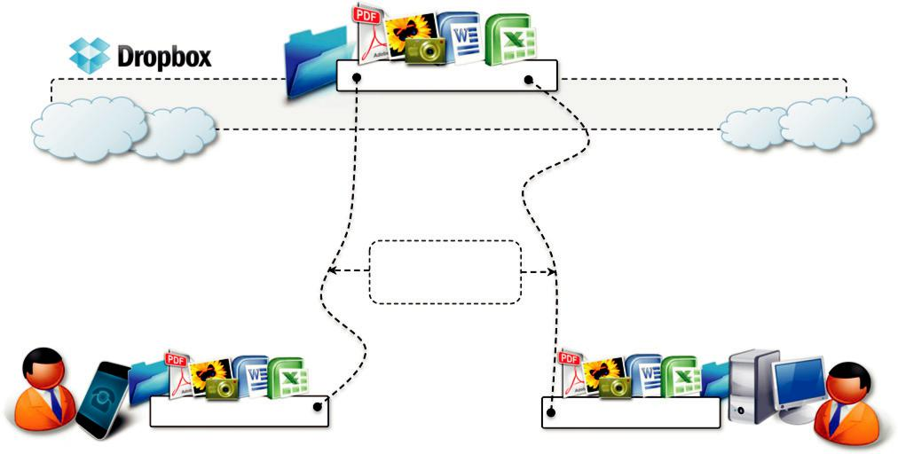

Dropbox Folder

Automatic

synchronization

Dropbox Folder Dropbox Folder

FIGURE 10.6

Dropbox usage scenario.

advantage of Dropbox is its availability on different platforms (Windows, Mac, Linux, and mobile) and the capability to work seamlessly and transparently across all of them.

Another interesting application in this area is iCloud, a cloud-based document-sharing applica-tion provided by Apple to synchronize iOS-based devices in a completely transparent manner. Unlike Dropbox, which provides synchronization through the abstraction of a local folder, iCloud has been designed to be completely transparent once it has been set up. Documents, photos, and videos are automatically synched as changes are made, without any explicit operation. This allows the system to efficiently automate common operations without any human intervention: taking a picture with your iPhone and having it automatically available in iPhoto on your Mac at home; editing a document on the iMac at home and having the changes updated in your iPad. Unfortunately, this capability is limited to iOS devices, and currently there are no plans to provide iCloud with a Web-based interface that would make user content accessible from even unsupported platforms.

There are other solutions for online document sharing, such as Windows Live, Amazon Cloud Drive, and CloudMe, that are popular and that we did not cover. These solutions offer more or less the same capabilities of those we’ve discussed, with different levels of integration between platform and devices.

10.2.2.2 Google docs

Google Docs is a SaaS application that delivers the basic office automation capabilities with sup-port for collaborative editing over the Web. The application is executed on top of the Google dis-tributed computing infrastructure, which allows the system to dynamically scale according to the number of users using the service.

Google Docs allows users to create and edit text documents, spreadsheets, presentations, forms, and drawings. It aims to replace desktop products such as Microsoft Office and OpenOffice and provide similar interface and functionality as a cloud service. It supports collaborative editing over the Web for most of the applications included in the suite. This eliminates tedious emailing and synchronization tasks when documents need to be edited by multiple users. By being stored in the Google infrastructure, these documents are always available from anywhere and from any device that is connected to the Internet. Moreover, the suite allows users to work offline if Internet connec-tivity is not available. Support for various formats such as those that are produced by the most pop-ular desktop office solutions allows users to easily import and move documents in and out of Google Docs, thus eliminating barriers to the use of this application.

Google Docs is a good example of what cloud computing can deliver to end users: ubiquitous access to resources, elasticity, absence of installation and maintenance costs, and delivery of core functionalities as a service.

Cloud desktops: EyeOS and XIOS/3

Asynchronous JavaScript and XML (AJAX) technologies have considerably augmented the capabili-ties that can be implemented in Web applications. This is a fundamental aspect for cloud computing, which delivers a considerable amount of its services through the Web browser. Together with the opportunity to leverage large-scale storage and computation, this technology has made possible the replication of complex desktop environments in the cloud and made them available through the Web browser. These applications, called cloud desktops, are rapidly gaining in popularity.
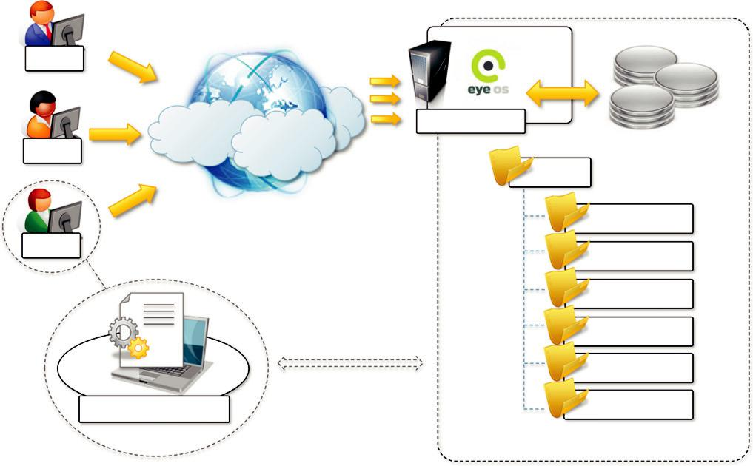

User

EyeOS Server

User

eyeos

apps

User
extern

extras

system

users

Client-side scripts | workgroups

FIGURE 10.7

EyeOS architecture.

EyeOS¹ is one of the most popular Web desktop solutions based on cloud technologies. It repli-cates the functionalities of a classic desktop environment and comes with pre-installed applications for the most common file and document management tasks (see Figure 10.7). Single users can access the EyeOS desktop environment from anywhere and through any Internet-connected device, whereas organizations can create a private EyeOS Cloud on their premises to virtualize the desktop environment of their employees and centralize their management.

The EyeOS architecture is quite simple: On the server side, the EyeOS application maintains the information about user profiles and their data, and the client side constitutes the access point for users and administrators to interact with the system. EyeOS stores the data about users and applications on the server file system. Once the user has logged in by providing credentials, the desktop environment is rendered in the client’s browser by downloading all the JavaScript libraries required to build the user interface and implement the core functionalities of EyeOS. Each applica-tion loaded in the environment communicates with the server by using AJAX; this communication model is used to access user data as well as to perform application operations: editing documents, visualizing images, copying and saving files, sending emails, and chatting.

EyeOS also provides APIs for developing new applications and integrating new capabilities into the system. EyeOS applications are server-side components that are defined by at least two files (stored in the eyeos/apps/appname directory): appname.php and appname.js. The first file defines

and implements all the operations that the application exposes; the JavaScript file contains the code that needs to be loaded in the browser in order to provide user interaction with the application.

Xcerion XML Internet OS/3 (XIOS/3) is another example of a Web desktop environment. The service is delivered as part of the CloudMe application, which is a solution for cloud document storage. The key differentiator of XIOS/3 is its strong leverage of XML, used to implement many of the tasks of the OS: rendering user interfaces, defining application business logics, structuring file system organization, and even application development.The architecture of the OS concentrates most of the functionalities on the client side while implementing server-based functionalities by means of XML Web services. The client side renders the user interface, orchestrates processes, and provides data-binding capabilities on XML data that is exchanged with Web services. The server is responsible for implementing core functions such as transaction management for documents edited in a collaborative mode and core logic of installed applications into the environment. XIOS/3 also provides an environment for developing applications (XIDE), which allows users to quickly develop complex applications by visual tools for the user interface and XML documents for business logic.

XIOS/3 is released as open-source software and implements a marketplace where third parties can easily deploy applications that can be installed on top of the virtual desktop environment. It is possible to develop any type of application and feed it with data accessible through XML Web ser-vices: developers have to define the user interface, bind UI components to service calls and opera-tions, and provide the logic on how to process the data. XIDE will package this information into a proper set of XML documents, and the rest will be performed by an XML virtual machine imple-mented in XIOS.

XIOS/3 is an advanced Web desktop environment that focuses on the integration of services into the environment by means of XML-based services and that simplifies collaboration with peers.

Social networking

Social networking applications have grown considerably in the last few years to become the most active sites on the Web. To sustain their traffic and serve millions of users seamlessly, services such as Twitter and Facebook have leveraged cloud computing technologies. The possibility of continuously adding capacity while systems are running is the most attractive feature for social networks, which constantly increase their user base.

Facebook

Facebook is probably the most evident and interesting environment in social networking. With more than 800 million users, it has become one of the largest Websites in the world. To sustain this incredible growth, it has been fundamental that Facebook be capable of continuously adding capac-ity and developing new scalable technologies and software systems while maintaining high perfor-mance to ensure a smooth user experience.

Currently, the social network is backed by two data centers that have been built and optimized to reduce costs and impact on the environment. On top of this highly efficient infrastructure, built and designed out of inexpensive hardware, a completely customized stack of opportunely modified and refined open-source technologies constitutes the back-end of the largest social network. Taken all together, these technologies constitute a powerful platform for developing cloud applications.

This platform primarily supports Facebook itself and offers APIs to integrate third-party applica-tions with Facebook’s core infrastructure to deliver additional services such as social games and quizzes created by others.

The reference stack serving Facebook is based on LAMP (Linux, Apache, MySQL, and PHP). This collection of technologies is accompanied by a collection of other services developed in-house. These services are developed in a variety of languages and implement specific functional-ities such as search, news feeds, notifications, and others. While serving page requests, the social graph of the user is composed. The social graph identifies a collection of interlinked information that is of relevance for a given user. Most of the user data are served by querying a distributed clus-ter of MySQL instances, which mostly contain key-value pairs. These data are then cached for faster retrieval. The rest of the relevant information is then composed together using the services mentioned before. These services are located closer to the data and developed in languages that provide better performance than PHP.

The development of services is facilitated by a set of internally developed tools. One of the core elements is Thrift. This is a collection of abstractions (and language bindings) that allow cross-language development. Thrift allows services developed in different languages to communi-cate and exchange data. Bindings for Thrift in different languages take care of data serialization and deserialization, communication, and client and server boilerplate code. This simplifies the work of the developers, who can quickly prototype services and leverage existing ones. Other relevant services and tools are Scribe, which aggregates streaming log feeds, and applications for alerting and monitoring.

Media applications

Media applications are a niche that has taken a considerable advantage from leveraging cloud com-puting technologies. In particular, video-processing operations, such as encoding, transcoding, com-position, and rendering, are good candidates for a cloud-based environment. These are computationally intensive tasks that can be easily offloaded to cloud computing infrastructures.

Animoto

Animoto is perhaps the most popular example of media applications on the cloud. The Website provides users with a very straightforward interface for quickly creating videos out of images, music, and video fragments submitted by users. Users select a specific theme for a video, upload the photos and videos and order them in the sequence they want to appear, select the song for the music, and render the video. The process is executed in the background and the user is notified via email once the video is rendered.

The core value of Animoto is the ability to quickly create videos with stunning effects without user intervention. A proprietary artificial intelligence (AI) engine, which selects the animation and transition effects according to pictures and music, drives the rendering operation. Users only have to define the storyboard by organizing pictures and videos into the desired sequence. If users don’t like the result, the video can be rendered again and the engine will select a different composition, thus producing a different outcome every time. The service allows users to create 30-second videos

for free. By paying a monthly or a yearly subscription it is possible to produce videos of any length and to choose among a wider range of templates.

The infrastructure supporting Animoto is complex and is composed of different systems that all need to scale (see Figure 10.8). The core function is implemented on top of the Amazon Web Services infrastructure. In particular, it uses Amazon EC2 for the Web front-end and the worker nodes; Amazon S3 for the storage of pictures, music, and videos; and Amazon SQS for connecting all the components. The system’s auto-scaling capabilities are managed by Rightscale, which moni-tors the load and controls the creation of new worker instances as well as their reclaim. Front-end nodes collect the components required to make the video and store them in S3. Once the storyboard of the video is completed, a video-rendering request is entered into a SQS queue. Worker nodes pick up rendering requests and perform the rendering. When the process is completed, another mes-sage is entered into a different SQS queue and another request is served. This last queue is cleared routinely and users are notified about the completion. The life of EC2 instances is controlled by Rightscale, which constantly monitors the load and the performance of the system and decides whether it is necessary to grow or shrink.

The architecture of the system has proven to be very scalable and reliable by using up to 4,000 servers on EC2 in peak times without dropping requests but simply causing acceptable temporary delays for the rendering process.
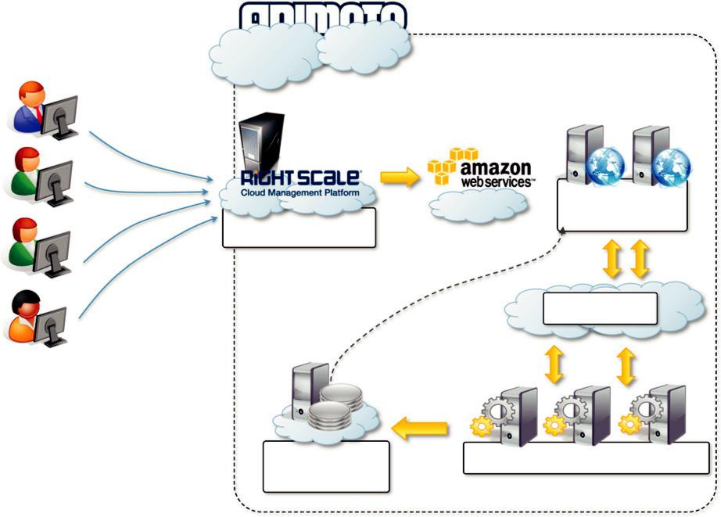

EC2 instances:
web front end
Scalability engine

Amazon SQS

Amazon S3: | EC2 instances: video rendering
Video storage

FIGURE 10.8

Animoto reference architecture.

Maya rendering with Aneka

Interesting applications of media processing are found in the engineering disciplines and the movie production industry. Operations such as rendering of models are now an integral part of the design workflow, which has become computationally demanding. The visualization of mechanical models is not only used at the end of the design process, it is iteratively used to improve the design. It is then fundamental to perform such tasks as fast as possible. Cloud computing provides engineers with the necessary computing power to make this happen.

A private cloud solution for rendering train designs has been implemented by the engineering department of GoFront group, a division of China Southern Railway (see Figure 10.9). The depart-ment is responsible for designing models of high-speed electric locomotives, metro cars, urban transportation vehicles, and motor trains. The design process for prototypes requires high-quality, three-dimensional (3D) images. The analysis of these images can help engineers identify problems and correct their design. Three-dimensional rendering tasks take considerable amounts of time, espe-cially in the case of huge numbers of frames, but it is critical for the department to reduce the time spent in these iterations. This goal has been achieved by leveraging cloud computing technologies, which turned the network of desktops in the department into a desktop cloud managed by Aneka.
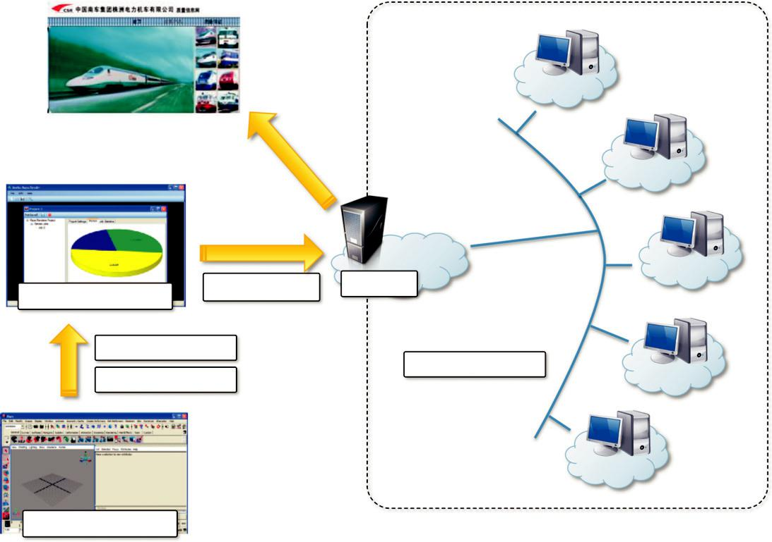

Aneka MayaRender | Render Tasks | Aneka

Render Files
Networked LAN
Scenarios

Maya: Train Design

FIGURE 10.9

3D rendering on private clouds.

The implemented system includes a specialized client interface that can be used by GoFront engi-neers to enter all the details of the rendering process (the number of frames, the number of cameras, and other parameters). The application is used to submit the rendering tasks to the Aneka Cloud, which distributes the load across all the available machines. Every rendering task triggers the exe-cution of the local Maya batch renderer and collects the result of the execution. The renders are then retrieved and put all together for visualization.

By turning the local network into a private cloud, the resources of which can be used off-peak (i.e., at night, when desktops are not utilized), it has been possible for GoFront to sensibly reduce the time spent in the rendering process from days to hours.

Video encoding on the cloud: Encoding.com

Video encoding and transcoding are operations that can greatly benefit from using cloud technolo-gies: They are computationally intensive and potentially require considerable amounts of storage. Moreover, with the continuous improvement of mobile devices as well as the diffusion of the Internet, requests for video content have significantly increased. The variety of devices with video playback capabilities has led to an explosion of formats through which a video can be delivered. Software and hardware for video encoding and transcoding often have prohibitive costs or are not flexible enough to support conversion from any format to any format. Cloud technologies present an opportunity for turning these tedious and often demanding tasks into services that can be easily integrated into a variety of workflows or made available to everyone according to their needs.

Encoding.com is a software solution that offers video-transcoding services on demand and leverages cloud technology to provide both the horsepower required for video conversion and the storage for staging videos. The service integrates with both Amazon Web Services technologies (EC2, S3, and CloudFront) and Rackspace (Cloud Servers, Cloud Files, and Limelight CDN access). Users can access the services through a variety of interfaces: the Encoding.com Website, Web service XML APIs, desktop applications, and watched folders. To use the service, users have to specify the location of the video to transcode, the destination format, and the target location of the video. Encoding.com also offers other video-editing operations such as the insertion of thumb-nails, watermarks, or logos. Moreover, it extends its capabilities to audio and image conversion.

The service provides various pricing options: monthly fee, pay-as-you-go (by batches), and spe-cial prices for high volumes. Encoding.com now has more than 2,000 customers and has already processed more than 10 million videos.

Multiplayer online gaming

Online multiplayer gaming attracts millions of gamers around the world who share a common expe-rience by playing together in a virtual environment that extends beyond the boundaries of a normal LAN. Online games support hundreds of players in the same session, made possible by the specific architecture used to forward interactions, which is based on game log processing. Players update the game server hosting the game session, and the server integrates all the updates into a log that is made available to all the players through a TCP port. The client software used for the game con-nects to the log port and, by reading the log, updates the local user interface with the actions of other players.

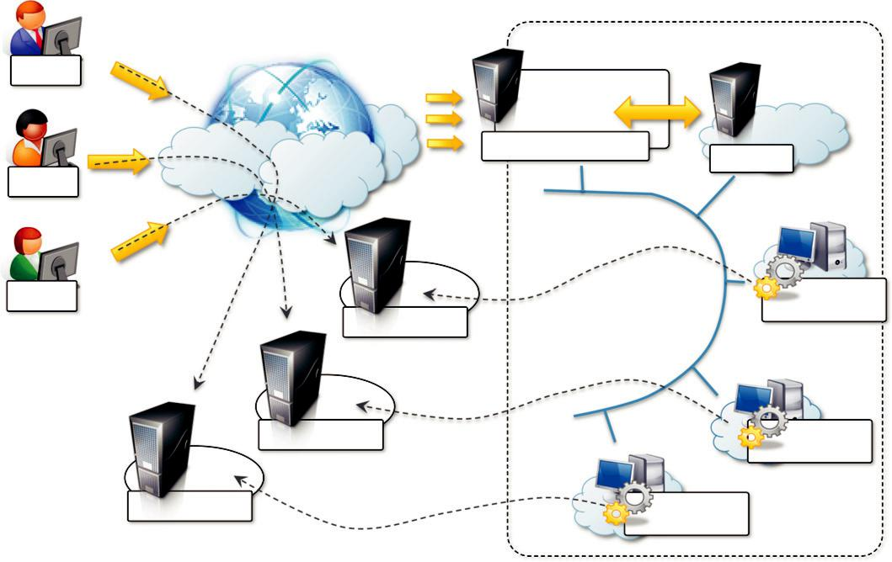

Gamer

Titan Gaming Portal

Gamer

Aneka

Gamer | Log
Game Server | Processing Task
Game Server | Log
 | Processing Task
Game Server | Log
 | Processing Task

FIGURE 10.10

Scalable processing of logs for network games.

Game log processing is also utilized to build statistics on players and rank them. These features constitute the additional value of online gaming portals that attract more and more gamers. The processing of game logs is a potentially compute-intensive operation that strongly depends on the number of players online and the number of games monitored. Moreover, gaming portals are Web applications and therefore might suffer from the spiky behavior of users that can randomly generate large amounts of volatile workloads that do not justify capacity planning.

The use of cloud computing technologies can provide the required elasticity for seamlessly pro-cessing these workloads and scale as required when the number of users increases. A prototypal implementation of cloud-based game log processing has been implemented by Titan Inc. (now Xfire), a company based in California that extended its gaming portal for offload game log proces-sing to an Aneka Cloud. The prototype (shown in Figure 10.10) uses a private cloud deployment that allowed Titan Inc. to process concurrently multiple logs and sustain a larger number of users.

CHAPTER
Advanced Topics in Cloud
Computing

Cloud computing is a rapidly moving target. New technological advances and application services are regularly introduced. There are many open challenges, especially in the context of energy-efficient management of datacenters and the marketplace for cloud computing.

This chapter presents an overview of various open issues in cloud computing that need long-term investigation. It discusses issues involved in energy-efficient cloud computing and presents a “green” cloud computing architecture. It discusses market models needed for realizing an open market for cloud computing systems from the perspective of federations of clouds and agreements between clouds. A general overview of some of the existing standards that enable interoperation between clouds and a brief look at third-party cloud services are presented.

Energy efficiency in clouds

Modern datacenters that operate under the cloud computing model are hosting a variety of applica-tions ranging from those that run for a few seconds (e.g., serving requests of Web applications such as ecommerce and social network portals) to those that run for longer periods of time (e.g., simula-tions or large dataset processing) on shared hardware platforms. The need to manage multiple applications in a datacenter creates the challenge of on-demand resource provisioning and alloca-tion in response to time-varying workloads. Normally, datacenter resources are statically allocated to applications based on peak load characteristics in order to maintain isolation and provide perfor-mance guarantees. Until recently, high performance has been the sole concern in datacenter deploy-ments, and this demand has been fulfilled without paying much attention to energy consumption. According to the McKinsey report on “Revolutionizing Data Center Energy Efficiency” [118], a typical datacenter consumes as much energy as 25,000 households. Energy costs of powering a typical data center doubles every five years. Because energy costs are increasing while availability dwindles, there is a need to shift focus from optimizing datacenter resource management for pure performance alone to optimizing for energy efficiency while maintaining high service-level perfor-mance (see Figure 11.1).

Datacenters are not only expensive to maintain, they are also unfriendly to the environment. Carbon emissions due to datacenters worldwide are now more than the emissions of both Argentina and the Netherlands [118]. High energy costs and huge carbon footprints are incurred due to the massive amount of electricity needed to power and cool the numerous servers hosted in these

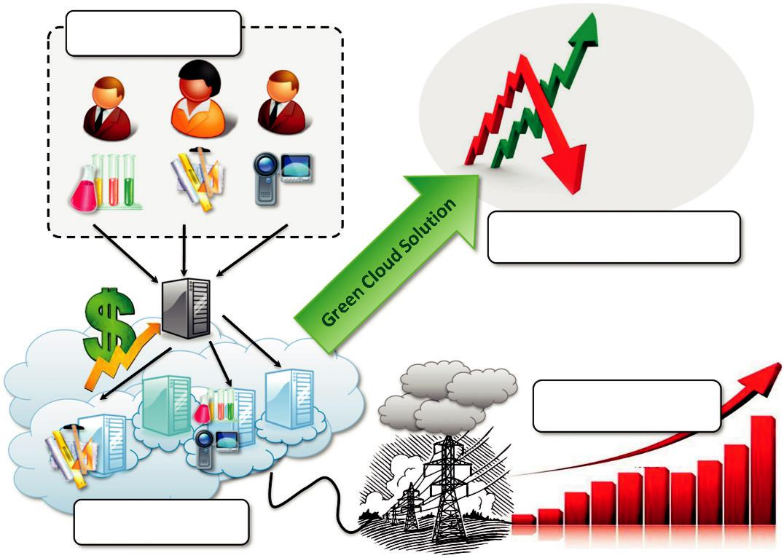

User Applications

Revenue

Power

Consumption

Reducing Power Cost and

Maximizing Revenue

Reducing Power Cost

and Carbon Emission

Cloud Data Center

FIGURE 11.1

A “green” cloud computing scenario.

datacenters. Cloud service providers need to adopt measures to ensure that their profit margins are not dramatically reduced due to high energy costs. According to Amazon’s estimate, the energy-related costs of its datacenters amount to 42% of the total budget, which includes both direct power consumption and the cooling infrastructure amortized over a 15-year period. As a result, companies such as Google, Microsoft, and Yahoo! are building large datacenters in barren desert land sur-rounding the Columbia River in the United States to exploit cheap hydroelectric power. There is also increasing pressure from governments worldwide to reduce carbon footprints, which have a significant impact on climate change. To address these concerns, leading IT vendors have recently formed a global consortium, called The Green Grid, to promote energy efficiency for datacenters and minimize their impact on the environment. Pike Research forecasts that datacenter energy expenditures worldwide will reduce from $23.3 billion in 2010 to $16.0 billion in 2020, as well as causing a 28% reduction in greenhouse gas (GHG) emissions from 2010 levels as a result of the adoption of the cloud computing model for delivering IT services.

Lowering the energy usage of datacenters is a challenging and complex issue because comput-ing applications and data are growing so quickly that larger servers and disks are needed to process them fast enough within the required time period. Green cloud computing is envisioned to achieve
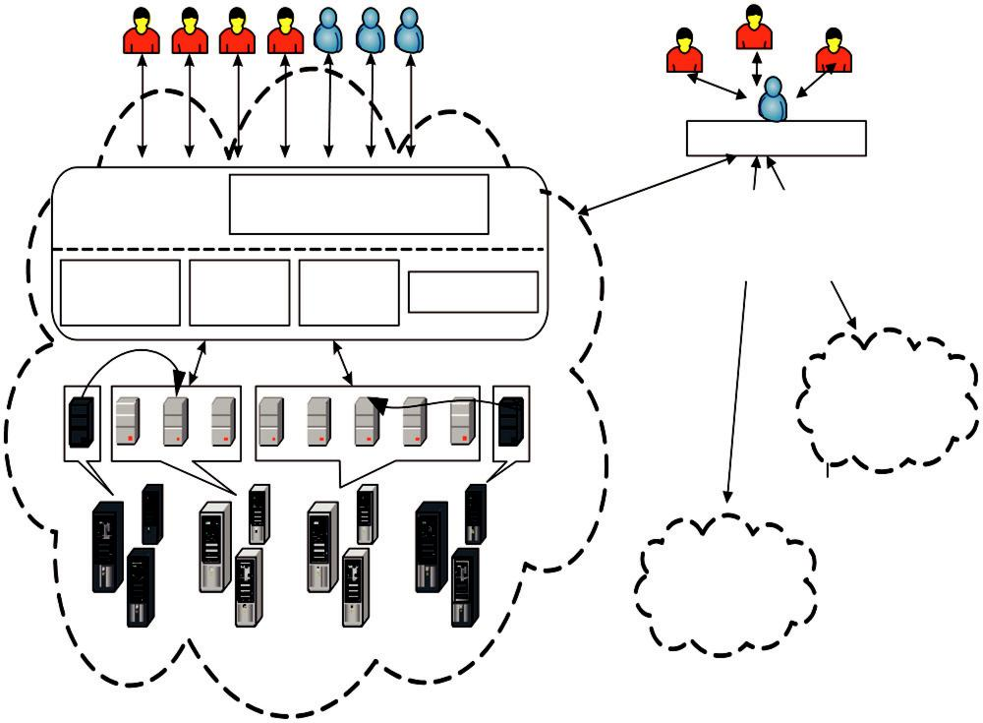

Consumers

(or their

Brokers)

Green Resource Manager

Virtual

Machines

(VMs)

Physical Machines

Cloud Broker

Admission |  | -SLA Negotiation |  | QoS and
Control |  | - Service Analyser |  | QoS and
Control |  |  |  | Energy-based
Service | VM | Energy | Accounting | provisioning
Scheduler | Manager | Monitor | Accounting

Cloud IaaS

Provider

Power Off Power On Power On Power Off

Cloud IaaS Provider

Cloud IaaS (Infrastructure-as-a-Service) Provider

FIGURE 11.2

High-level system architectural framework for green cloud computing.

not only efficient processing and utilization of computing infrastructure but also minimize energy consumption. This is essential for ensuring that the future growth of cloud computing is sustainable. Cloud computing, with increasingly pervasive front-end client devices such as iPhones interacting with back-end datacenters, will cause an enormous escalation in energy usage. To address this problem, datacenter resources need to be managed in an energy-efficient manner to drive green cloud computing. In particular, cloud resources need to be allocated not only to satisfy QoS requirements specified by users via service-level agreements (SLAs) but also to reduce energy usage. This can be achieved by applying market-based utility models to accept user requests that can be fulfilled to enhance revenue along with energy-efficient utilization of cloud infrastructure.

Energy-efficient and green cloud computing architecture

A high-level architecture for supporting energy-efficient resource allocation in a green cloud com-puting infrastructure is shown in Figure 11.2. It consists of four main components:

Consumers/brokers. Cloud consumers or their brokers submit service requests from anywhere in the world to the cloud. It is important to note that there can be a difference between cloud

consumers and users of deployed services. For instance, a consumer can be a company deploying a Web application, which presents varying workloads according to the number of “users” accessing it.

Green Resource Allocator. Acts as the interface between the cloud infrastructure and consumers. It requires the interaction of the following components to support energy-efficient resource management:

Green Negotiator. Negotiates with the consumers/brokers to finalize the SLAs with specified prices and penalties (for violations of SLAs) between the cloud provider and the consumer, depending on the consumer’s QoS requirements and energy-saving schemes. In Web applications, for instance, the QoS metric can be 95% of requests being served in less than 3 seconds.

Service Analyzer. Interprets and analyzes the service requirements of a submitted request before deciding whether to accept or reject it. Hence, it needs the latest load and energy information from VM Manager and Energy Monitor, respectively.

Consumer Profiler. Gathers specific characteristics of consumers so that important consumers can be granted special privileges and prioritized over other consumers.

Pricing. Decides how service requests are charged to manage the supply and demand of computing resources and facilitate prioritizing service allocations effectively.

Energy Monitor. Observes and determines which physical machines to power on or off.

Service Scheduler. Assigns requests to VMs and determines resource entitlements for allocated VMs. It also decides when VMs are to be added or removed to meet demand.

VM Manager. Keeps track of the availability of VMs and their resource entitlements. It is also in charge of migrating VMs across physical machines.

Accounting. Maintains the actual usage of resources by requests to compute usage costs. Historical usage information can also be used to improve service allocation decisions.

VMs. Multiple VMs can be dynamically started and stopped on a single physical machine to meet accepted requests, hence providing maximum flexibility to configure various partitions of resources on the same physical machine to different specific requirements of service requests. Multiple VMs can also run concurrently applications based on different operating system environments on a single physical machine. In addition, by dynamically migrating VMs across physical machines, workloads can be consolidated and unused resources can be put on a low-power state, turned off, or configured to operate at low performance levels (e.g., using Dynamic Voltage and Frequency Scaling, or DVFS) to save energy.

Physical machines. The underlying physical computing servers provide hardware infrastructure for creating virtualized resources to meet service demands.

Energy-aware dynamic resource allocation

Recent developments in virtualization have resulted in its use across datacenters. Virtualization enables dynamic migration of VMs across physical nodes according to QoS requirements. Unused VMs can be logically resized and consolidated on a minimal number of physical nodes, while idle nodes can be turned off (or hibernated). Through consolidation of VMs, large numbers of users can share a single physical server, which increases utilization and in turn reduces the total number of servers required. Moreover, VM consolidation can be applied dynamically by capturing the workload variability and adapting the VM placement at runtime using migration.

Currently, resource allocation in a cloud datacenter aims at providing high performance while meeting SLAs, with limited or no consideration for energy consumption during VM allocations. However, to explore both performance and energy efficiency, two crucial issues must be addressed. First, turning off resources in a dynamic environment puts QoS at risk; aggressive consolidation may cause some VMs to obtain insufficient resources to serve a spike in load. Second, agreed SLAs bring challenges to application performance management in virtualized environments. These issues require effective consolidation policies that can minimize energy use without compromising user QoS requirements. The current approaches to dynamic VM consolidation are weak in terms of providing performance guarantees. One of the ways to prove performance bounds is to divide the problem of energy-efficient dynamic VM consolidation into a few subproblems that can be ana-lyzed individually. It is important to analytically model the problem and derive optimal and near-optimal approximation algorithms that provide provable efficiency. To achieve this goal, clouds need novel analytical models and QoS-based resource allocation algorithms that optimize VM placements with the objective of minimizing energy consumption under performance constraints.

InterClouds and integrated allocation of resources

Cloud providers have been deploying datacenters in multiple locations throughout the globe. For example, Amazon EC2 Cloud services are available via Amazon datacenters located in the United States, Europe, and Singapore. This disbursement is leading to the emergence of a notion, called the InterCloud, supporting scalable delivery of application services by harnessing multiple datacenters from one or more providers. In addition to enhancing performance and reliability, these InterClouds provide a powerful means of reducing energy-related costs. One reason is that the local demand for electricity varies with time of day and weather. This causes time-varying differences in the price of electricity at each location.Moreover, each site has a different source of energy (such as coal, hydroelectric, or wind), with different environmental costs.This gives scope to adjust the load sent to each location, and the number of servers powered on at each location, to improve efficiency.

In such environments, algorithms that make routing decisions by considering the location of the user, the energy-efficiency of the hardware at each site, the energy mix, and the number of servers currently on at each location are needed. A particularly promising approach is to use this routing to make work “follow the renewables.”A major problem with renewable energy is that most sources are intermittent and uncontrollable.Dynamically routing requests to locations with available renew-able energy can greatly reduce the nonrenewable energy used and facilitate the widespread use of clean energy.

Sending loads to remote datacenters incurs both delay costs and energy costs due to the increased amounts of data that are transferred over the Internet. Improvements in energy-efficient transport technology should lead to significant reductions in the power consumption of the cloud software services [120].

Market-based management of clouds

Cloud computing is still in its infancy, and its prominent use is twofold: (1) complete replacement of in-house IT infrastructure and services with the same capabilities rented by service providers;

and (2) elastic scaling of existing computing systems in order to address peak workloads. The efforts in research and industry have been mostly oriented to design and implement systems that actually enable business vendors and enterprises to achieve these goals. The real potential of cloud computing resides in the fact that it actually facilitates the establishment of a market for trad-ing IT utilities. This opportunity until now has been mildly explored and falls in the domain of what it is called market-oriented cloud computing [30].

Market-oriented cloud computing

Cloud computing already embodies the concept of providing IT assets as utilities. Then, what makes cloud computing different from market-oriented cloud computing? First, it is important to understand what we intend by the term market. The Oxford English Dictionary (OED)¹ defines a market as a “place where a trade is conducted” (Def. I). More precisely, market refers to a meeting or a gathering together of people for the purchase and sale of goods. A broader characterization defines the term market as the action of buying and selling, a commercial transaction, a purchase, or a bargain. Therefore, essentially the word market is the act of trading mostly performed in an environment—either physical or virtual—that is specifically dedicated to such activity.

If we consider the way IT assets and services are consumed as utilities, it is evident that there is a trade-off between the service provider and the consumer; this enables the use of the service by the user under a given SLA. Therefore, cloud computing already expresses the concept of trade, even though the interaction between consumer and provider is not as sophisticated as happens in real markets: Users generally select one cloud computing vendor from among a group of competing providers and leverage its services as long as they need them. Moreover, at present, most service providers have inflexible pricing, generally limited to flat rates or tariffs based on usage thresholds. In addition, many providers have proprietary interfaces to their services, thus restricting the ability of consumers to quickly move—and with minimal conversion costs—from one vendor to another. This rigidity, known as vendor lock-in, undermines the potential of cloud computing to be an open market where services are freely traded. Therefore, to remove such restrictions, it is required that vendors expose services through standard interfaces. This enables full commoditization and thus would pave the way for the creation of a market infrastructure for trading services.

What differentiates market-oriented cloud computing (MOCC) from cloud computing is the presence of a virtual marketplace where IT services are traded and brokered dynamically. This is something that still has to be achieved and that will significantly evolve the way cloud computing services are eventually delivered to the consumer. More precisely, what is missing is the availabil-ity of a market where desired services are published and then automatically bid on by matching the requirements of customers and providers. At present, some cloud computing vendors are already moving in this direction²; this phenomenon is happening in the IaaS domain—which is the market

sector that is more consolidated and mature for cloud computing—but it has not taken off broadly yet. We can clearly characterize the relationship between cloud computing and MOCC as follows:

Market Oriented Computing has the same characteristics as Cloud Computing; therefore it is a dynamically provisioned unified computing resource allowing you to manage software and data storage as on aggregate capacity resulting in “real-time” infrastructure across public and private infrastructures. Market Oriented Cloud Computing goes one step further by allowing spread into multiple public and hybrid environments dynamically composed by trading service. [122]

The realization of this vision is technically possible today but is not probable, given the lack of standards and overall immaturity of the market. Nonetheless, it is expected that in the near future, with the introduction of standards, concerns about security and trust will begin to disappear and enterprises will feel more comfortable leveraging a market-oriented model for integrating IT infra-structure and services from the cloud. Moreover, the presence of a demand-based marketplace represents an opportunity for enterprises to shape their infrastructure for dynamically reacting to workload spikes and for cutting maintenance costs. It also allows the possibility to temporarily lease some in-house capacity during low usage periods, thus giving a better return on investment. These developments will lead to the complete realization of market-oriented cloud computing.

A reference model for MOCC

Market-oriented cloud computing originated from the coordination of several components: service consumers, service providers, and other entities that make trading between these two groups possi-ble. Market orientation not only influences the organization on the global scale of the cloud com-puting market. It also shapes the internal architecture of cloud computing providers that need to support a more flexible allocation of their resources, which is driven by additional parameters such as those defining the quality of service.

A global view of market-oriented cloud computing

A reference scenario that realizes MOCC at a global scale is given in Figure 11.3. It provides guid-ance on how MOCC can be implemented in practice.

Several components and entities contribute to the definition of a global market-oriented architecture. The fundamental component is the virtual marketplace—represented by the Cloud Exchange (CEx)—which acts as a market maker, bringing service producers and consumers together. The principal players in the virtual marketplace are the cloud coordinators and the cloud brokers. The cloud coordinators represent the cloud vendors and publish the services that vendors offer. The cloud brokers operate on behalf of the consumers and identify the subset of services that match customers’ requirements in terms of service profiles and quality of service. Brokers perform the same function as they would in the real world: They mediate between coordi-nators and consumers by acquiring services from the first and subleasing them to the latter. Brokers can accept requests from many users. At the same time, users can leverage different brokers. A similar relationship can be considered between coordinators and cloud computing services vendors. Coordinators take responsibility for publishing and advertising services on behalf of vendors and can gain benefits from reselling services to brokers. Every single participant has its own utility function, that they all want to optimize rewards. Negotiations and trades are carried out in a secure

Users

Brokers
Negotiate

Bid

Enterprise Resource

Server (Proxy)

Enterprise IT Consumer

= Cloud Coordinator

FIGURE 11.3

VMM
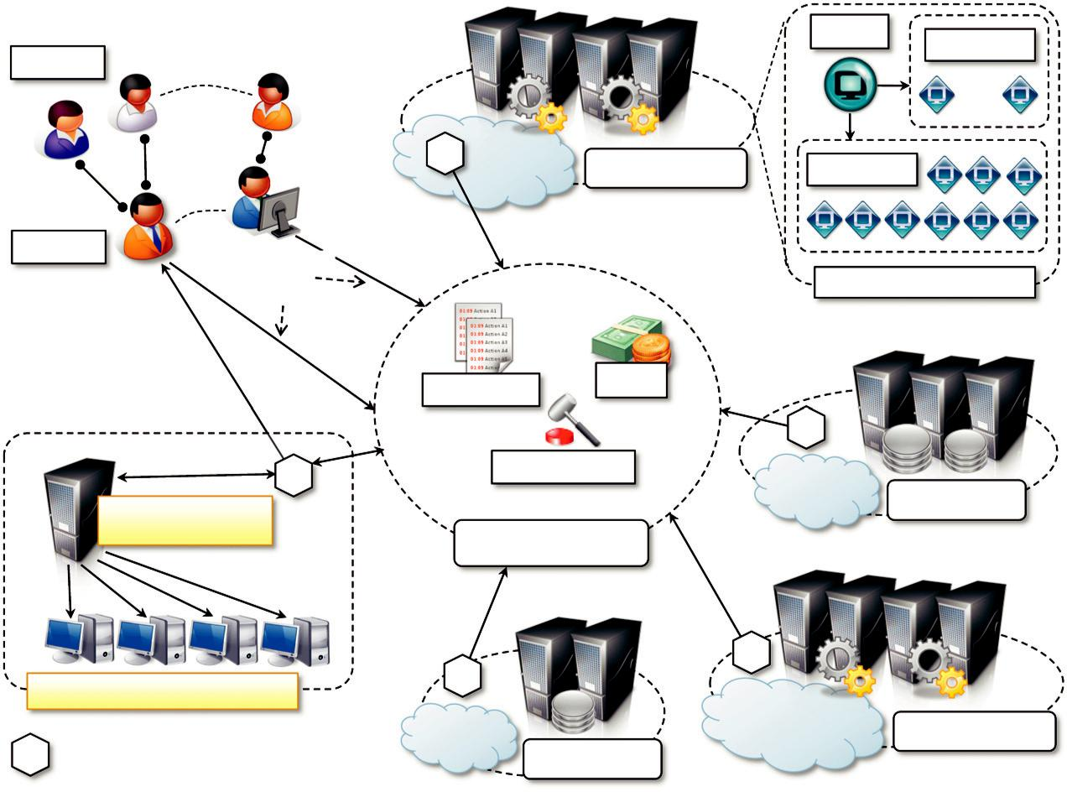
Pool Node

Compute Cloud Pool Node

Cluster (VM Pool)

Directory ^{Bank}

Auctioneer

Storage Cloud

Cloud Exchange

Compute Cloud

Storage Cloud

Market-oriented cloud computing scenario.

and dependable environment and are mostly driven by SLAs, which each party has to fulfill. There might be different models for negotiation among entities, even though the auction model seems to be the more appropriate in the current scenario. The same consideration can be made for the pricing models: Prices can be fixed, but it is expected that they will most likely change according to market conditions.

Several components contribute to the realization of the Cloud Exchange and implement its fea-tures. In the reference model depicted in Figure 11.3, it is possible to identify three major components:

Directory. The market directory contains a listing of all the published services that are available in the cloud marketplace. The directory not only contains a simple mapping between service names and the corresponding vendor (or cloud coordinators) offering them. It also provides additional metadata that can help the brokers or the end users in filtering from among the services of interest those that can really meet the expected quality of service. Moreover, several indexing methods can be provided to optimize the discovery of services according to various criteria. This component is modified in its content by service providers and queried by service consumers.

Auctioneer. The auctioneer is in charge of keeping track of the running auctions in the marketplace and of verifying that the auctions for services are properly conducted and that malicious market players are prevented from performing illegal activities.

Bank. The bank is the component that takes care of the financial aspect of all the operations happening in the virtual marketplace. It also ensures that all the financial transactions are carried out in a secure and dependable environment. Consumers and providers may register with the bank and have one or multiple accounts that can be used to perform the transactions in the virtual marketplace.

This organization, as described, constitutes only a reference model that is used to guide system architects and designers in laying out the foundations of a Cloud Exchange system. In reality, the architecture of such a system is more complex and articulated since other elements have to be taken into account. For instance, since the cloud marketplace supports trading, which ultimately involves financial transactions between different parties, security becomes of fundamental importance. It is then important to put in place all the mechanisms that enable secure electronic transactions. These and other aspects are not unique to the design and implementation of MOCC systems but are of concern for any distributed computing system; therefore, they have been only mentioned here.

Market-oriented architecture for datacenters

Datacenters are the building blocks of the computing infrastructure that backs the services offered by a cloud computing vendor, no matter its specific category (IaaS, PaaS, or SaaS). In this section, we present these systems by taking into account the elements that are fundamental for realizing computing infrastructures that support MOCC. These criteria govern the logical organization of these systems—rather than their physical layout and hardware characteristics—and provide guid-ance for designing architectures that are market oriented. In other words, we describe a reference architecture for MOCC datacenters.

Figure 11.4 provides an overall view of the components that can support a cloud computing pro-vider in making available its services on a market-oriented basis [123]. More specifically, the
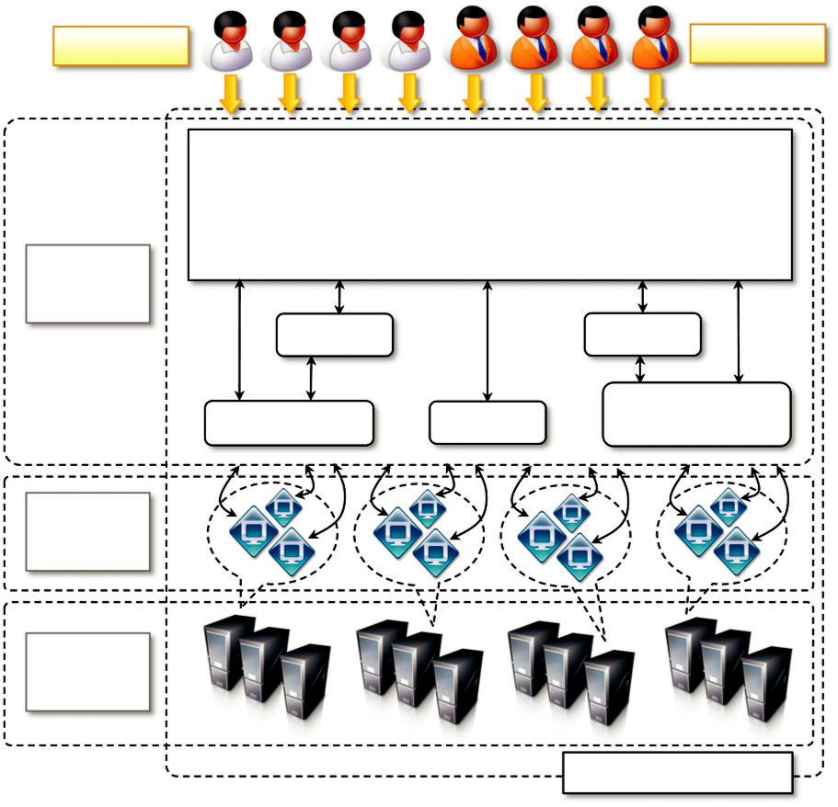

Users Brokers

Service Request Examiner and Admission Control

 | - Customer-driven Service Management
 | - Computational Risk Management
SLA | - Autonomic Resource Management
Allocator
 | Pricing |  | Accounting
 | VM Monitor | Dispatcher | Service Request
 | VM Monitor | Dispatcher | Monitor

Virtual

Machines

Physical

Machines

Cloud Data Center

FIGURE 11.4

Reference architecture for a cloud datacenter.

model applies to PaaS and IaaS providers that explicitly leverage virtualization technologies to serve customers’ needs. There are four major components of the architecture:

Users and brokers. They originate the workload that is managed in the cloud datacenter. Users either require virtual machine instances to which to deploy their systems (IaaS scenario) or deploy applications in the virtual environment made available to them by the provider (PaaS scenario). These service requests are issued by service brokers that act on behalf of users and look for the best deal for them.

SLA resource allocator. The allocator represents the interface between the datacenter and the cloud service provider and the external world. Its main responsibility is ensuring that service requests are satisfied according to the SLA agreed to with the user. Several components coordinate allocator activities in order to realize this goal:

Service Request Examiner and Admission Control Module. This module operates in the front-end and filters user and broker requests in order to accept those that are feasible given

the current status of the system and the workload that is already processing. Accepted requests are allocated and scheduled for execution. IaaS service providers allocate one or more virtual machine instances and make them available to users. PaaS providers identify a suitable collection of computing nodes to which to deploy the users’ applications.

Pricing Module. This module is responsible for charging users according to the SLA they signed. Different parameters can be considered in charging users; for instance, the most common case for IaaS providers is to charge according to the characteristics of the virtual machines requested in terms of memory, disk size, computing capacity, and the time they are used. It is very common to calculate the usage in time blocks of one hour, but several other pricing schemes exist. PaaS providers can charge users based on the number of requests served by their application or the usage of internal services made available by the development platform to the application while running.

Accounting Module. This module maintains the actual information on usage of resources and

stores the billing information for each user. These data are made available to the Service Request Examiner and Admission Control module when assessing users’ requests. In addition, they constitute a rich source of information that can be mined to identify usage trends and improve the vendor’s service offering.

Dispatcher. This component is responsible for the low-level operations that are required to realize admitted service requests. In an IaaS scenario, this module instructs the infrastructure to deploy as many virtual machines as are needed to satisfy a user’s request. In a PaaS scenario, this module activates and deploys the user’s application on a selected set of nodes; deployment can happen either within a virtual machine instance or within an appropriate sandboxed environment.

Resource Monitor. This component monitors the status of the computing resources, either physical or virtual. IaaS providers mostly focus on keeping track of the availability of VMs and their resource entitlements. PaaS providers monitor the status of the distributed middleware, enabling the elastic execution of applications and loading of each node.

Service Request Monitor. This component keeps track of the execution progress of service requests. The information collected through the Service Request Monitor is helpful for analyzing system performance and for providing quality feedback about the provider’s capability to satisfy requests. For instance, elements of interest are the number of requests satisfied versus the number of incoming requests, the average processing time of a request, or its time to execution. These data are important sources of information for tuning the system.

The SLA allocator executes the main logic that governs the operations of a single datacenter or a collection of datacenters. Features such as failure management are most likely to be addressed by other software modules, which can either be a separate layer or can be integrated within the SLA resource allocator.

Virtual machines (VMs). Virtual machines constitute the basic building blocks of a cloud computing infrastructure, especially for IaaS providers. VMs represent the unit of deployment for addressing users’ requests. Infrastructure management software is in charge of keeping operational the computing infrastructure backing the provider’s commercial service offering. As we discussed, VMs play a fundamental role in providing an appropriate hosting environment for users’ applications and, at the same time, isolate application execution from the infrastructure, thus preventing applications from harming the hosting environment. Moreover,

VMs are among the most important components influencing the QoS with which a user request is served. VMs can be tuned in terms of their emulated hardware characteristics so that the amount of computing resource of the physical hardware allocated to a user can be finely controlled. PaaS providers do not directly expose VMs to the final user, but they may internally leverage virtualization technology in order to fully and securely utilize their own infrastructure. As previously discussed, PaaS providers often leverage given middleware for executing user applications and might use different QoS parameters to charge application execution rather than the emulated hardware profile.

Physical machines. At the lowest level of the reference architecture resides the physical infrastructure that can comprise one or more datacenters. This is the layer that provides the resources to meet service demands.

This architecture provides cloud services vendors with a reference model suitable to enabling their infrastructure for MOC. As mentioned, these observations mostly apply to PaaS and IaaS pro-viders, whereas SaaS vendors operate at a higher abstraction level. Still, it is possible to identify some of the elements of the SLA resource allocator, which will be modified to deal with the ser-vices offered by the provider. For instance, rather than linking user requests to virtual machine instances and platform nodes, the allocator will be mostly concerned with scheduling the execution of requests within the provider’s SaaS framework, and lower layers in the technology stack will be in charge of controlling the computing infrastructure. Accounting, pricing, and service request monitoring will still perform their roles.

Regardless of the specific service offering category, the reference architecture discussed here aims to support cloud computing vendors in delivering commercial solutions that are able to [123]:

Support customer-driven service management based on customer profiles and requested service requirements

Define computational risk management tactics to identify, assess, and manage risks involved in the execution of applications with regard to service requirements and customer needs

Derive appropriate market-based resource management strategies encompassing both customer-driven service management and computational risk management in order to sustain SLA-oriented resource allocation

Incorporate autonomic resource management models that effectively self-manage changes in service requirements to satisfy both new service demands and existing service obligations

Leverage—when appropriate—VM technology to dynamically assign resource shares according to service requirements

These capabilities are of fundamental importance for competitiveness in the cloud computing market and for addressing a scenario characterized by dynamic SLA negotiations as envisioned by MOCC. Currently, there is no or limited support for such a dynamic negotiation model, which constitutes the next step toward the full realization of cloud computing.

Technologies and initiatives supporting MOCC

Existing cloud computing solutions have very limited support for market-oriented strategies to deliver services to customers. Most current solutions mainly focused on enabling cloud computing

concern the delivery of infrastructure, distributed runtime environments, and services. Since cloud computing has been recently adopted, the consolidation of the technology constitutes the first step toward the full realization of its promise. Until now, a good deal of interest has been directed toward IaaS solutions, which represent a well-consolidated sector in the cloud computing market, with several different players and competitive offers. New PaaS solutions are gaining momentum, but it is harder for them to penetrate the market dominated by giants such as Google, Microsoft, and Force.com.

Framework for trading computing utilities

From an academic point of view, a considerable amount of research has been carried out in defin-ing models that enable the trading of computing utilities, with a specific focus on the design of market-oriented schedulers for grid computing systems. As discussed in the introduction, computing grids aggregate a heterogeneous set of resources that are geographically distributed and might belong to different organizations. Such resources are often leased for long-term use by means of agreements among these organizations. Within this context, market-oriented schedulers, which are aware of the price of a given computing resource and schedule user’s applications according to their budgets, have been investigated and implemented. The research in this area is of relevance to MOCC, since cloud computing leverages preexisting distributed computing technologies, including grid computing.

Garg and Buyya [124] have provided a complete taxonomy and analysis of such schedulers, which is reported in Figure 11.5. A major classification categorizes these schedulers according to allocation decision, objective, market model, application model, and participant focus. Of particular interest is the classification according to the market model, which is the mechanism used for trad-ing between users and providers. Along this dimension, it is possible to classify the schedulers into the following categories:

Game theory. In market models that are based on game theory, participants interact in the form of an allocation game, with different payoffs as a result of specific actions that employ various strategies.

Proportional share. This market model originates from proportional share scheduling, which aims to allocate jobs fairly over a set of resources. This original concept has been contextualized within a market-oriented scenario in which the shares of the cluster are directly proportional to the user’s bid.

Commodity market. In this model the resource provider specifies the price of resources and charges users according to the amount of resources they consume. The provider’s determination of the price is the result of a decision process involving investment and management costs, current demand, and supply. Moreover, prices might be subject to vary over time.

Posted price. This model is similar to the commodity market, but the provider may make special offers and discounts to new clients. Furthermore, with respect to the commodity market, prices are fixed over time.

Contract-Net. In market models based on the Contract-Net [125] protocol, users advertise their demand and invite resource owners to submit bids. Resource owners check these advertisements with respect to their requirements. If the advertisement is favorable to them, the providers will respond with a bid. The user will then consolidate all the bids and compare them to select those
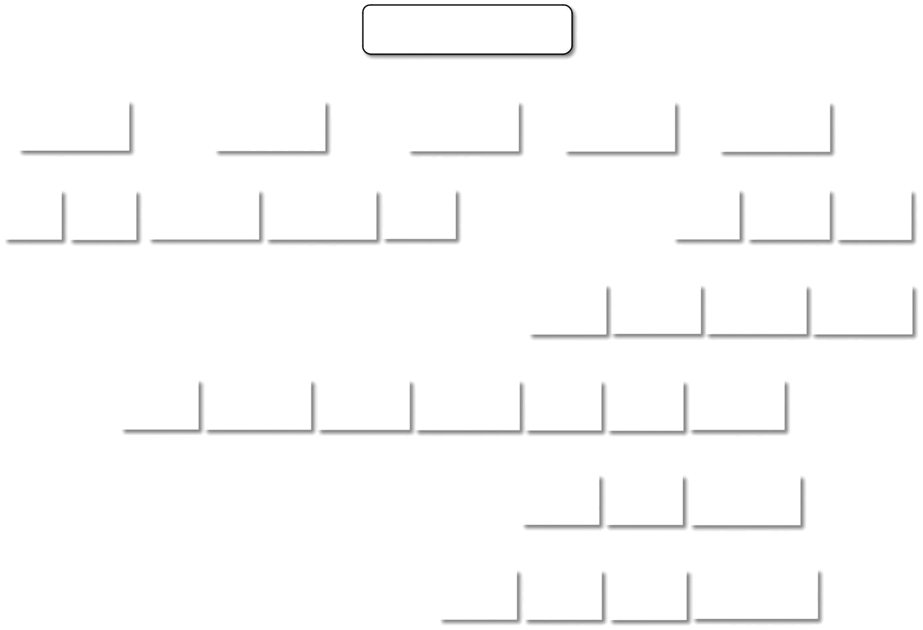

Market-Oriented Models

 |  | Allocation |  |  |  |  |  |  |  |  |  |  |  | Objective |  |  |  |  |  |  |  |  |  |  |  |  |  | Market |  |  |  |  |  |  |  | Application |  |  |  |  |  |  |  |  |  |  |  |  |  | Participant
 |  | Decision |  |  |  |  |  |  |  |  |  |  |  |  |  |  |  |  |  |  |  |  |  |  |  |  |  | Model |  |  |  |  |  |  |  |  | Model |  |  |  |  |  |  |  |  |  |  |  |  |  |  | Focus
Local |  |  |  |  | Global |  |  |  |  |  | Profit-based |  |  |  |  |  |  | System-based |  |  |  |  |  | Hybrid |  |  |  |  |  |  |  |  |  |  |  |  |  |  |  |  |  |  |  |  | User |  |  |  |  |  |  | Resource |  |  |  |  |  |  |  |  | System
 |  |  |  |  |  |  |  |  |  |  |  |  |  |  |  |  |  |  |  |  |  |  |  |  |  |  |  |  |  |  |  |  |  |  |  |  |  |  |  |  |  |  |  | Centric |  |  |  |  |  |  |  | Centric |  |  |  |  |  |  |  |  | Centric
 |  |  |  |  |  |  |  |  |  |  |  |  |  |  |  |  |  |  |  |  |  |  |  |  |  |  |  |  |  |  |  |  |  | Bag of |  |  |  |  | Workflow |  |  |  |  |  |  |  |  |  | Parallel |  |  |  |  |  |  |  |  |  |  |  | Others
 |  |  |  |  |  |  |  |  |  |  |  |  |  |  |  |  |  |  |  |  |  |  |  |  |  |  |  |  |  |  |  |  |  | Tasks |  |  |  |  |  |  |  |  |  |  |  |  | Applications |  |  |  |  |  |  |  |  |  |  |  | eg. Storage
 |  |  |  |  |  |  |  |  | Game |  |  |  |  | Proportional |  |  |  |  |  |  | Bargaining |  |  |  |  |  | Commodity |  |  |  |  |  |  | Posted |  |  |  |  | Auction |  |  |  |  |  |  |  | Contract
 |  |  |  |  |  |  |  |  | Theory |  |  |  |  | Share |  |  |  |  |  |  |  |  |  |  |  |  |  | Market |  |  |  |  |  | Price |  |  |  |  |  |  |  |  |  |  |  |  |  | Net
 |  |  |  |  |  |  |  |  |  |  |  |  |  |  |  |  |  |  |  |  |  |  |  |  |  |  |  |  |  |  |  |  |  | Single |  |  |  |  | Double |  |  |  |  |  |  | Combinatorial
 |  |  |  |  |  |  |  |  |  |  |  |  |  |  |  |  |  |  |  |  |  |  |  |  |  |  |  |  |  |  |  |  |  | Sided |  |  |  |  | Auction |  |  |  |  |  |  |  |  | Auction
 |  |  |  |  |  |  |  |  |  |  |  |  |  |  |  |  |  |  |  |  |  |  |  |  |  |  |  |  | Vickery |  |  |  |  | Dutch |  |  |  |  | English |  |  |  |  |  |  |  |  | First Price
 |  |  |  |  |  |  |  |  |  |  |  |  |  |  |  |  |  |  |  |  |  |  |  |  |  |  |  | Auction |  |  |  |  |  | Auction |  |  |  |  | Auction |  |  |  |  |  |  |  | Sealed Auction

FIGURE 11.5

Market-oriented scheduler taxonomy.

most favorable to him. The providers are then informed about the outcome of their bids, which can be acceptance or rejection.

Bargaining. In market models based on bargaining, the negotiation among resource consumers and providers is carried out until a mutual agreement is reached or it is stopped when either of the parties is no longer interested.

Auction. In market models based on auctions, the price of resources is unknown, and competitive bids regulated by a third party—the auctioneer—contribute to determining the final price of a resource. The bid that ultimately sets the price of a resource is the winning bid, and the corresponding user gains access to the resource.

The most popular and interesting market models for trading computing utilities are the commod-ity market, posted price, and auction models. Commodity market and posted price models, or varia-tions/combinations of them, are driving the majority of cloud computing services offerings today. Auction-based models can instead potentially constitute the reference market-models for MOCC, since they are able to seamlessly support dynamic negotiations.

Academic research has led to the development of a considerable number of software projects that implement either user resource brokers or resource management systems able to trade comput-ing utilities according to one, or some, of the market models described previously. Some of them— namely SHARP [126], Tycoon [127], Bellagio [128], and Shirako [129]—have focused on trading VM-based resource slices and are more likely to be applicable within the MOCC scenario. In addi-tion, it is worth noting some relevant research projects focusing on resource brokering, such as Nimrod-G [164] and Gridbus Broker [15], which have evolved to integrate capabilities for leasing cloud computing resources.

Industrial implementations

Even though market-oriented models have been mostly developed in the academic domain, indus-trial implementations of some aspects of MOCC are becoming available and gaining popularity. In particular, some interesting initiatives show how different aspects of MOCC, such as flexible pricing models, virtual market place, and market directories, have been made available to the wider public.

Flexible pricing models: amazon spot instances

Amazon Web Services (AWS), one of the biggest players in the IaaS market, recently introduced the concept of spot instances,³ which allows EC2 customers to bid on unused Amazon EC2 capac-ity and run those instances for as long as their bid exceeds the current spot price. The spot price varies periodically according to the supply of and demand for EC2 instances and is kept constant within a single hour block. Spot instances can be terminated at any time, and they are usually priced at a lower price with respect to the traditional (on-demand and reserved) instances, since they rely on exceeding capacity available in the EC2 infrastructure. Therefore, it is the responsibil-ity of the user to periodically persist the state of applications executing within spot instances. Spot instances represent an interesting opportunity for both Amazon and EC2 users to benefit from the current condition of the market: The provider can make revenue from a capacity that would have

been wasted if priced at the normal level, and the consumer has the opportunity to pay less by taking major risks.

Despite their volatile nature, spot instances have been demonstrated to be reasonably reliable and usable for performing tasks that have a lower priority and are not critical. In other words, they are suitable for applications that can tolerate QoS limitations. Moreover, they are profitably used to extend the capacity of an existing infrastructure at lower costs [130].

Virtual market place: SpotCloud

SpotCloud⁴ is an online portal that implements a virtual marketplace, where sellers and buyers can register and trade cloud computing services. The platform is a market place operating in the IaaS sector. Buyers are looking for compute capacity that can meet the requirements of their applica-tions, while sellers can make available their infrastructure to serve buyers’ needs and earn revenue. SpotCloud provides a comprehensive set of features that are expected for a virtual marketplace. Some of them include:

Detailed logging of all the buyers’ transactions

Full metering, billing for any capacity

Full control over pricing and availability of capacity in the market

Management of quotas and utilization levels for providers

Federation management (many providers, many customers, but one platform)

Hybrid cloud support (internal and external resource management)

Full market administration and reporting

Applications and pre-build appliances directories

Besides being an online portal, the virtual market realized by SpotCloud can also be replicated in the private premises. Transactions are carried out with real money and based on credit that buyers and sellers must top up once they create an account.

SpotCloud is the most representative implementation of a platform that enables MOCC, even though with some limitations. SpotCloud’s working principle is a common and unique platform that sellers need to share in order to join the portal and make available computing capacity. SpotCloud currently supports Enomaly ECP⁵ and OpenStack.⁶

Market directories: AppSpot, the cloud market

SpotCloud is implemented as an application hosted on AppSpot. This is a huge portal serving appli-cations built on top of the Google AppEngine infrastructure: appspot.com is a namespace under which all the scalable Web applications developed with the Google AppEngine technology are made available to the community of Internet users. A solution that is more oriented toward listing available cloud building blocks is The Cloud Market,⁷ which features a comprehensive listing of Amazon EC2 images. Even though these solutions do not provide a complete implementation of a

market directory, they constitute a step toward the realization of MOCC, since they provide a means to easily locate components useful in building cloud computing systems.

A case study: the cloudbus toolkit

An interesting case study coming from research is the Cloudbus toolkit [131]. This is a collection of technologies and components that comprehensively try to address the challenges involved in realizing the vision of market-oriented cloud computing.

Figure 11.6 provides a comprehensive view of the Cloudbus components and how they interact together to provide a platform for MOCC. Real-life applications belonging to various scenarios, such as finance, science, education, engineering, multimedia, and others, require cloud computing facilities for processing their workloads and storing data.

The Cloudbus toolkit can act as a general front-end by providing mediated access to cloud com-puting services that best serve applications’ needs. It does so by making available tools and tech-nologies to implement a service-brokering infrastructure and middleware for deploying applications in the cloud. Brokering services are implemented by the Market Maker, which allows users to take full advantage of the cloud marketplace. It relies on different middleware implementations to fulfill the requests of users; these can be either Cloudbus technologies or third-party implementations. Technologies such as Aneka or Workflow Engine provide services for executing applications in the cloud. These can be public clouds, private intranets, or datacenters that can all be uniformly man-aged within an InterCloud [114] realm, which federates computing clouds that belong to different organizations into a unique domain characterizing agreements among parties.

Table 11.1 provides an overview of all the components that constitute the Cloudbus Toolkit, together with a brief description of their function. The toolkit also includes facilities for developing algorithms and deployments in a simulated environment by means of CloudSim [132]. This is a toolkit that enables users to simulate many aspects of cloud computing environments, from the basic building blocks of a cloud (datacenters, computing nodes, cores, network, and virtual machines) to the resource allocation algorithms and policies. As an example of its versatility, the toolkit has been used to simulate power-aware scheduling policies [133] for reducing energy con-sumption in large datacenters.

Observations

In this section we have briefly reviewed the fundamental concepts of market-oriented cloud com-puting. As with any technology, there exists a consolidation phase during which the concepts laying out its foundations are investigated, experimented, absorbed, and leveraged. Cloud computing is a relative evolution of distributed computing and has provided new ways to deliver IT infrastructure and services in a more efficient way to both enterprise and single users. Initially, considerable development interest and effort have been oriented toward the consolidation of the IaaS sector and its integration within the existing computing systems and workflow processes. Currently, PaaS solu-tions are gaining popularity and being used more consistently to deliver commercial and main-stream software applications and systems. This is the appropriate context where technologies and systems supporting MOCC can be implemented and made available. Most of the work done in this sense still belongs to the domain of academic research, even though the first commercial and industrial implementations are reaching the wider audience.

 | physics | optimization |  | risk analysis | 3D rendering
 | biology | modeling |  | banking | imaging | blogging
 | medicine | CAD | teaching | finance |  | photos
Applications | science | engineering | education | business | multimedia | social
 |  |  |  |  |  | ….
 |  |  |  |  | networking
Models | bag of tasks | parameter sweep | workflow | message passing | map-reduce | ….
Technology |  | Web 2.0 Interfaces: Ajax, Web Services, Service Portals, REST
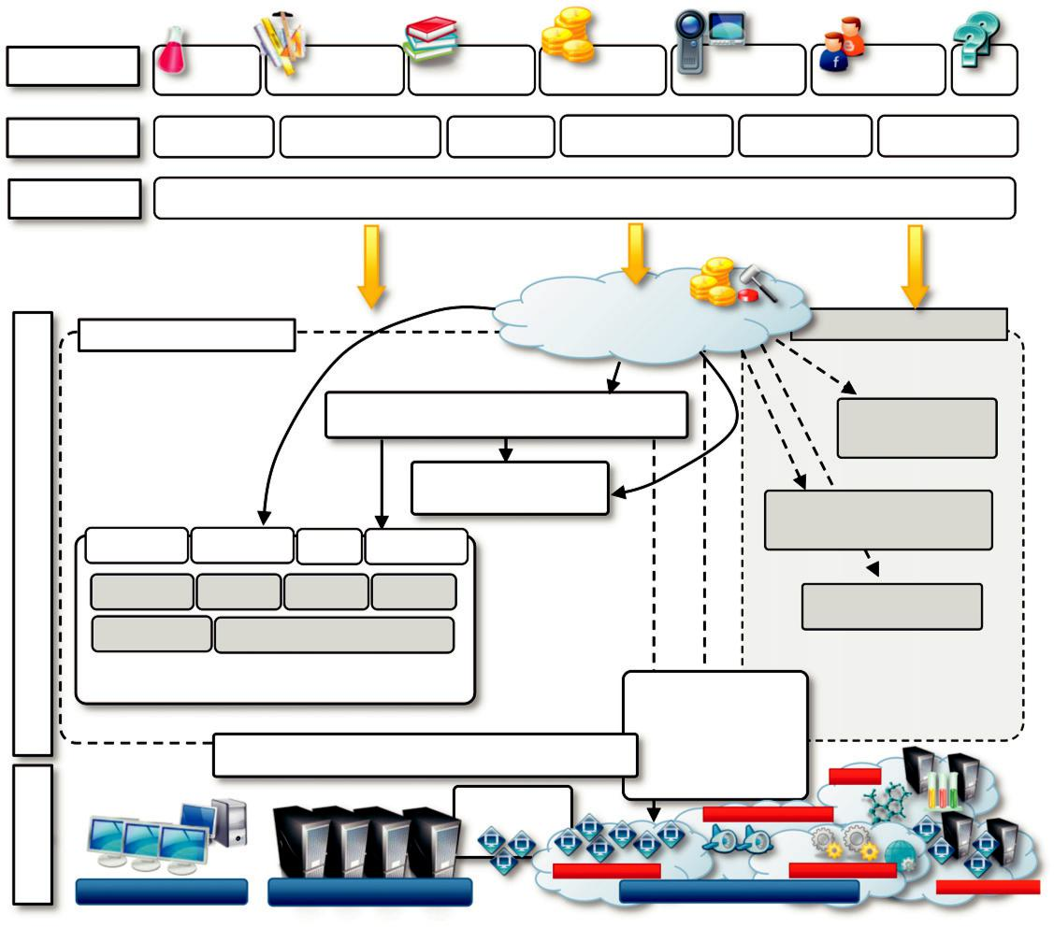

Core Technologies

Infrastructure

 |  |  |  | Market Maker
Cloudbus Middleware |  |  |  | Meta-broker | Other Middleware
 |  |  |  | Workflow Engine | PaaS Vendor 1
 |  |  |  | Broker
 |  |  |  |  | PaaS Vendor 2
Task Model | Thread Model | PSM | MapReduce
Accounting | Metering | Pricing | Billing |  | PaaS Vendor 3
QoS and SLA | Res. Provisioning & Reservation
 | Aneka
 | Scalable Execution Application Manager |  |  |  | InterCloud
 |  |  |  |  | OSC
 |  |  |  | PEX | Google AppEngine
 |  |  |  |  | C
 |  |  |  | Amazon EC2 / S3 | Microsoft Azure
Desktop Computers |  | Cluster Datacenter |  | Public Cloud Infrastructure |  | IBM Blue Cloud

FIGURE 11.6

Cloudbus Toolkit.

Federated clouds/InterCloud

In the previous section we discussed how to define models and systems for trading computing resources as utilities and how cloud computing systems can interact with each other to make this trading happen. In this section, we address the same problem from the administrative and organiza-tional points of view and introduce the concept of cloud federation and the InterCloud. These are enablers for MOCC since they provide means for interoperation among different cloud providers.

Cloud computing strongly implies the presence of financial agreements between parties, since services are available on demand on a pay-per-use basis. Nonetheless, the concepts characterizing



Table 11.1 Cloudbus Toolkit Components and Technologies

Technology | Description
Aneka | Middleware for cloud applications development and deployment.
Broker | Middleware for scheduling distributed applications across heterogeneous systems
 | based on the bag-of-tasks model.
Workflow management | Middleware for the execution, composition, management, and monitoring of
system | workflows across heterogeneous systems.
Market Maker/Meta- | A matchmaker that matches the user’s requirements with service providers’
Broker | capabilities within the context of a marketplace.
InterCloud | A framework for the federation of independent computing clouds.
MetaCDN | Middleware that leverages storage clouds for intelligently delivering users’ content
 | based on their QoS and budget preferences.
Energy-efficient | Ongoing research on developing techniques and technologies for addressing
computing | scalability and energy efficiency.

cloud federation and the InterCloud are applicable, with some limitations, to building aggregations of clouds that belong to different administrative domains.

Characterization and definition

The terms cloud federation and InterCloud, often used interchangeably, convey the general mean-ing of an aggregation of cloud computing providers that have separate administrative domains. It is important to clarify what these two terms mean and how they apply to cloud computing.

The term federation implies the creation of an organization that supersedes the decisional and administrative power of the single entities and that acts as a whole.⁸ Within a cloud computing con-text, the word federation does not have such a strong connotation but implies that there are agree-ments between the various cloud providers, allowing them to leverage each other’s services in a privileged manner. A definition of the term cloud federation was given by Reuven Cohen, founder and CTO of Enomaly Inc.⁹ :

Cloud federation manages consistency and access controls when two or more independent geo-graphically distinct Clouds share either authentication, files, computing resources, command and control or access to storage resources.

This definition is broad enough to include all the different expressions of cloud services aggre-gations that are governed by agreements between cloud providers, rather than composed by the user.

InterCloud is a term that is often used interchangeably to express the concept of Cloud federa-tion. It was introduced by Cisco for expressing a composition of clouds that are interconnected by

means of open standards to provide a universal environment that leverages cloud computing ser-vices. By mimicking the Internet term, often referred as the “network of networks,” InterCloud represents a “Cloud of Clouds”¹⁰ and therefore expresses the same concept of federating together clouds that belong to different administrative organizations. Whereas this is in many cases accept-able, some practitioners and experts—like Ellen Rubin, founder and VP of Products at CloudSwitch¹¹ —prefer to give different connotations to the two terms:

The primary difference between the InterCloud and federation is that the InterCloud is based on future standards and open interfaces, while federation uses a vendor version of the control plane. With the InterCloud vision, all Clouds will have a common understanding of how applications should be deployed. Eventually workloads submitted to a Cloud will include enough of a defini-tion (resources, security, service level, geo-location, etc.) that the Cloud is able to process the request and deploy the application. This will create the true utility model, where all the require-ments are met by the definition and the application can execute “as is” in any Cloud with the resources to support it.

Therefore, the term InterCloud refers mostly to a global vision in which interoperability among different cloud providers is governed by standards, thus creating an open platform where applica-tions can shift workloads and freely compose services from different sources. On the other hand, the concept of a cloud federation is more general and includes ad hoc aggregations between cloud providers on the basis of private agreements and proprietary interfaces.

Cloud federation stack

Creating a cloud federation involves research and development at different levels: conceptual, logi-cal and operational, and infrastructural. Figure 11.7 provides a comprehensive view of the chal-lenges faced in designing and implementing an organizational structure that coordinates together cloud services that belong to different administrative domains and makes them operate within a context of a single unified service middleware.

Each cloud federation level presents different challenges and operates at a different layer of the IT stack. It then requires the use of different approaches and technologies. Taken together, the solu-tions to the challenges faced at each of these levels constitute a reference model for a cloud federation.

Conceptual level

The conceptual level addresses the challenges in presenting a cloud federation as a favorable solu-tion with respect to the use of services leased by single cloud providers. In this level it is important to clearly identify the advantages for either service providers or service consumers in joining a fed-eration and to delineate the new opportunities that a federated environment creates with respect to the single-provider solution. Elements of concern at this level are:

Motivations for cloud providers to join a federation

Motivations for service consumers to leverage a federation

Advantages for providers in leasing their services to other providers

Obligations of providers once they have joined the federation

Trust agreements between providers

Transparency versus consumers

Among these aspects, the most relevant are the motivations of both service providers and consu-mers in joining a federation.

From the perspective of cloud service providers, being part of federation is favorable if it helps increase their revenue and if it provides new opportunities to increase their business. Moreover, the option of joining a federation can also be considered convenient if it helps sustain the QoS ensured to customers in periods of peak load, which put extreme demand on the infrastructure of the single provider. More precisely, it is possible to identify functional and nonfunctional requirements that cloud service providers have behind these motivations. The functional requirements include:

Supplying low-latency access to customers, regardless of their location. It is very unlikely that single cloud providers have a capillary distribution of their datacenters. Therefore, services that require low latency might provide poor performance because of unfortunate geo-location. Within this scenario the federation might help the single providers deliver the same service and meet the expected QoS.
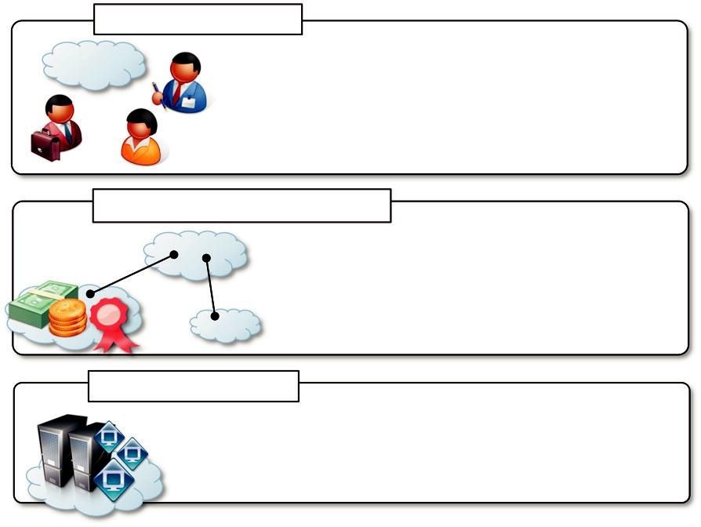

Conceptual Level

Motivations

Advantages

Opportunities

Obligations

Logical and Operational Level

Federation Model

Cloud Service, Provider, Agreements

Market and Pricing Models

Service Level Agreements

Infrastructural Level

Protocol, Interfaces, and Standards

Programmatic Interoperation

Federation Platforms (RESERVOIR, InterCloud)

FIGURE 11.7

Cloud federation reference stack.

Handling bursts in demand. Even though cloud computing gives the illusion of infinite capacity and continuous availability, service providers rely on a finite IT infrastructure that eventually will be fully utilized. A natural solution to this problem is increasing the infrastructure by adding more capacity. For example, to keep up with the increasing demand for storage and computation, Google has increased its number of servers from 8,000 to more than 450,000 in five years and moved from four server farms to more than 60 datacenters; Facebook has recently doubled its datacenter capacity. Such huge provisions are affordable for large IT companies that can make appropriate forecasts about increasing demand. Irregular demand can be better addressed by renting capacity from other providers, since not every cloud provider is in the position of being an IT giant. Cloud federation facilitates such activity by providing a context within which the lease of resources or services is encouraged.

Scaling existing applications and services beyond the capabilities of the owned infrastructure. The need for additional capacity can also originate from the growth in scale of existing applications that are temporarily hosted and do not constitute a vital part of the service provider core business. Again, the opportunities for leasing additional services from a federated provider can constitute a potential advantage for a cloud federation.

Make revenue from unused capacity. To provide the illusion of continuous availability and infinite capacity, cloud service providers generally own large computing systems, which generate costs in terms of maintenance and power consumption despite their real use. Energy-efficient computing solutions can help reduce costs and the impact of IT on the environment. A different opportunity is given by the cloud federation, whereby providers can lease their services to other providers for a limited period of time and thus make revenue, even without direct customers.

The motivations for joining a cloud federation also include nonfunctional requirements.

The most relevant are the following:

Meeting compulsory regulations about the location of data. Geo-location might become an in issue that limits a provider’s capability to serve consumers. In this particular scenario it is not lack of capacity on the provider side that is the reason for leveraging the federation but, instead, the opportunity for identifying a provider that is in a position to deliver the service to the customer because of the location of its datacenter. Geo-location of data becomes an important matter when cloud services deal with confidential data that require specific levels of secrecy. Different countries have different regulations with respect to, for instance, the level of access to confidential data that government institutions may have.

Containing transient spikes in operational costs. Operational costs can experience temporary spikes when there is a sudden change in electrical power due to natural disasters. This situation makes it inconvenient to fully exploit a given datacenter and provides an opportunity for leveraging federation resources to deliver services a cheaper price.

Disaster recovery. Natural disasters happen, and if datacenters are co-located a disaster can put an entire datacenter or more out of service for an undefined period of time. In this scenario agreements between providers to handle disaster conditions are more likely to be settled in a federated context than in a competitive market.

For all these cases, cloud federation helps provide not only conceptual solutions but also practical means to realize these goals.

Cloud federation is an overlay that mostly benefits cloud service providers and that is supposed to be transparent to service consumers. Besides the indirect benefits to end users, there are indeed some potential direct benefits originating specifically from the concept of federation. Indirect benefits are mostly related to the QoS perceived by the end users. Real QoS is possible by enforcing admission control, which ensures that if a request is accepted, it will be served in compliance with the QoS pro-file defined in the SLA signed with the customer. Currently, the major cloud service providers engage QoS agreements that are mostly based on availability rather than other quality factors. For instance, in an IaaS scenario the published hardware features of a VM instance might not mirror its real performance. Since there is no SLA enforcement of such features, the provider will always try to serve requests, even when risking delivery of poor performance. In a federated scenario, requests may be served by leveraging other providers, thus ensuring that the expected performance profile is met. Therefore, as indirect benefit for users, cloud federation can help increase the overall QoS the user experiences when requesting a service. Direct benefits instead constitute something that is an advantage to end users, and they are perceivable because of the existence of federated clouds.

Cloud providers that offer different services can support each other since they are not competi-tors. A good example can be taken from the cooperation between the airline and accommodation market segments. Airline companies provide you with selected options for accommodation to be paired with a flight booking. This is generally the result of an agreement between the hotel and air-line companies that might support each other, thus providing better service to the customer. Since companies operating in the two sectors are not competing with each other, they can both gain advantage if they provide customers with a complete solution. It is possible to replicate this type of collaboration in a federated cloud computing environment. For instance, providers that reside in dif-ferent market segments (IaaS, PaaS, SaaS) might advertise each other to provide better service to the user. Enterprises that have legacy systems will be primarily looking at IaaS solutions to deploy and scale their systems. IaaS vendors can complement their offerings with advantageous access to some PaaS services by selecting those that might be complementary, of interest to the user, and offered by federated providers.

In the future, Amazon AWS might provide discounted access to AppEngine or simply provide a better interaction with the services exposed by Google in terms of data transfer, network connec-tion, and bandwidth. How does this help the customer? The same company that is already hosting its Web application on Amazon EC2 might in the future want to integrate new features and develop them with a scalable technology. Due to performance advantages gained in leveraging AppEngine from an EC2 deployment, this could be the solution of choice. This is more likely to be possible within the context of a cloud federation. Moreover, federated clouds can provide better service to users, even when they reside in the same market segment but provide different services. For instance, in an IaaS scenario a specific provider might not be able to serve VM templates for host-ing a specific operating system, but it can suggest or point the customer to another provider that’s able to supply that capability. This scenario is applicable if the two providers have mutual agree-ments that are facilitated by belonging to a federation.

Being part of a federation also implies providers’ obligations to avoid parasitic behaviors. For instance, each provider is expected to be an active member of the federation by contributing its

resources. This makes an organization such as the federation dependable and increases the trust that each provider puts in it. Obligations, such as always making available a fraction of resources and services to the federation, might be considered disadvantages, but they may also constitute potential benefits. For instance, large companies such as Google are charged for energy usage according to the peak requests rather than detailed actual usage over a month [135]. This means that if in one month a datacenter reaches 90% of peak capacity and on average works at 60%, it will pay power bills for the cost of operating at 90% capacity for the entire month. This has led companies to put a lot of effort into optimizing the utilization of datacenters. A cloud federation might be an alternative to frenetic optimization, since it might make internal resources available for usage by other member of the federation. The revenue obtained from leasing these resources is an opportunity to compensate the energy costs for peak request.

All these aspects provide a rationale for the existence of federated clouds. Obstacles at the con-ceptual level are the implications for security and trust. For instance, in a federated context a pro-vider might offload a portion of the service consumers’ requests to another provider with which it has agreements. This is done transparently to the user, who might not desire such behavior. These are challenges that have to be properly addressed in order to make the concept of cloud federation a viable way to efficiently exploit cloud computing as a technology.

Logical and operational level

The logical and operational level of a federated cloud identifies and addresses the challenges in devising a framework that enables the aggregation of providers that belong to different administra-tive domains within a context of a single overlay infrastructure, which is the cloud federation. At this level, policies and rules for interoperation are defined. Moreover, this is the layer at which decisions are made as to how and when to lease a service to—or to leverage a service from— another provider. The logical component defines a context in which agreements among providers are settled and services are negotiated, whereas the operational component characterizes and shapes the dynamic behavior of the federation as a result of the single providers’ choices. This is the level where MOCC is implemented and realized.
It is important at this level to address the following challenges:

How should a federation be represented?

How should we model and represent a cloud service, a cloud provider, or an agreement?

How should we define the rules and policies that allow providers to join a federation?

What are the mechanisms in place for settling agreements among providers?

What are providers responsibilities with respect to each other?

When should providers and consumers take advantage of the federation?

Which kinds of services are more likely to be leased or bought?

How should we price resources that are leased, and which fraction of resources should we lease?

The logical and operational level provides opportunities for both academia and industry. Whereas the need for a federation—or more generally, some sort of interoperation—has now been assessed, there is no common and clear guideline for defining a model for cloud federation and addressing these challenges. Indeed, several initiatives are developing. On the research side, several works are investigating organizational models for cloud interoperability and studying economical models for describing the behavior of cloud service providers and service consumers in a federated

environment. Within industry, the major IT giants are working on promoting standards and drafting proposals for interoperable clouds.

Particular attention on this level has been put on the necessity for SLAs and their definition

The need for SLAs is an accepted fact in both academy and industry, since SLAs define more clearly what is leased or bought between different providers. Moreover, SLAs allow us to assess whether the services traded are delivered according to the expected quality profile. It is then possible to specify policies that regulate the transactions among providers and establish penalties in case of degraded service delivery. This is particularly important because it increases the level of trust that each party puts in cloud federation.

SLAs have been in use since 1980 and originated in the telecommunications domain [152] to define the QoS attached to a contract between a consumer and a network provider. From there on, they have been used in several fields, including Web services, grid computing, and cloud comput-ing. The specific nature of SLA varies from domain to domain, but it can be generally defined as

“an explicit statement of expectations and obligations that exist in a business relationship between two organizations: the service provider and the service consumer.¹²” SLAs define the provider’s performance delivery ability, the consumer’s performance profile, and the means to monitor and measure the delivered performance. An implementation of an SLA should specify [153]:

Purpose. Objectives to achieve by using a SLA.

Restrictions. Necessary steps or actions that need to be taken to ensure that the requested level of service is delivered.

Validity period. Period of time during which the SLA is valid.

Scope. Services that will be delivered to the consumer and services that are outside the SLA.

Parties. Any involved organizations or individual and their roles (e.g. provider, consumer).

Service-level objectives (SLOs). Levels of services on which both parties agree. These are expressed by means of service-level indicators such as availability, performance, and reliability.

Penalties. The penalties that will occur if the delivered service does not achieve the defined SLOs.

Optional services. Services that are not mandatory but might be required.

Administration. Processes that are used to guarantee that SLOs are achieved and the related organization responsibilities for controlling these processes.

Parties that are willing to operate under an SLA engage a multistep process that generally involves the discovery or creation of the SLA, its operational phase, and its termination once its validity is over or there has been a violation of the contract [154]. A more articulated process has been detailed by the Sun Internet Data Center Group, which includes six steps for the SLA life cycle:

Discover service provider.

Define SLA.

Establish agreement.

Monitor SLA violation.

Terminate SLA.

Enforce penalties for SLA violation.

Currently, a very rudimentary level of SLA management is present and the interoperability among different cloud providers is mostly characterized by ad hoc aggregation. The proposed pro-cess constitutes a reference model that still needs to be realized rather than a common implementa-tion. Considerable work has been done in the academic domain regarding each of the steps defined here [150], but within industry, SLAs are still unilateral arrangements that are imposed by service providers and that the user can only accept rather than negotiate.

Infrastructural level

The infrastructural level addresses the technical challenges involved in enabling heterogeneous cloud computing systems to interoperate seamlessly. It deals with the technology barriers that keep separate cloud computing systems belonging to different administrative domains. By having stan-dardized protocols and interfaces, these barriers can be overcome. In other words, this level for the federation is what the TCP/IP stack is for the Internet: a model and a reference implementation of the technologies enabling the interoperation of systems.

The infrastructural level lays its foundations in the IaaS and PaaS layers of the Cloud Computing Reference Model (discussed in Section 4.2). Services for interoperation and interface may also find implementation at the SaaS level, especially for the realization of negotiations and of federated clouds. At this level it is important to address the following issues:

What kind of standards should be used?

How should design interfaces and protocols be designed for interoperation?

Which are the technologies to use for interoperation?

How can we realize a software system, design platform components, and services enabling interoperability?

Interoperation and composition among different cloud computing vendors is possible only by means of open standards and interfaces. Moreover, interfaces and protocols change considerably at each layer of the Cloud Computing Reference Model. As the more mature layer, the IaaS layer has evolved more in this sense. Almost every IaaS provider exposes Web interfaces for packaging virtual machine templates, launching, monitoring, and terminating virtual instances. Even though not standardized, these interfaces leverage the Web services and are quite similar to each other. The use of a common technology simplifies the interoperation among vendors, since a minimum amount of code is required to enable such interoperation. These APIs allow for defining an abstrac-tion layer that uniformly accesses the services of several IaaS vendors. There are already tools—both open-source and commercial—and specifications that provide interoperability by implementing such a layer.

To fully support the vision of a cloud federation, more sophisticated capabilities need to be implemented. For instance, the possibility of dynamically moving virtual machine instances among different providers is essential to supporting dynamic load balancing among different IaaS vendors. In this direction, the Open Virtualization Format (OVF) [51] aims to be a solution for this problem and may eventually be successful, since it has been endorsed by several cloud computing vendors. If we consider the PaaS layer, the interoperations become even harder since each cloud computing vendor provides its own runtime environment, which might differ from others in terms of imple-mentation language, abstractions used to develop applications, and purpose. Currently, there is no

sign of interoperation at this level and no proposed standards simplifying the interoperation among vendors. Regarding the SaaS layer, the variety of services offered makes the operation less crucial.

An interesting case for interoperability at the SaaS layer is provided by online office automation solutions such as Google Documents, Zoho Office, and others; several of them provide the capabil-ity to export and import documents to and from different formats, thus simplifying the exchange of data. Alternatively, composition seems to be a more attractive opportunity; different SaaS services can be glued together to provide users with more complex applications. Composition is also impor-tant in considering interoperability across cloud computing platforms operating at different layers. Even in this case it is important to note that, currently, cloud computing providers operating at one layer often implement on their own infrastructure any lower layer that is required to provide the service to the end user, and they are not willing to open their stack of technologies to support interoperation.

The vision proposed by a federated environment of cloud service vendors still poses a lot of challenges at each level, especially the logical and infrastructural level, where appropriate system organizations need to be designed and effective technologies need to be deployed. Considerable research effort has been carried out on the logical and operational level, and initial implementations and drafts of interoperable technologies are now developed especially for the IaaS market segment.

Aspects of interest

Several aspects contribute to the successful realization of a cloud federation. Besides motivation and technical enablers, other elements should be considered. In particular, standards for interopera-bility, security, and legal issues have to been taken into consideration while defining a platform for interoperability among cloud vendors.

Standards

Standards play a fundamental role in building a federation. Their main role is to organize a plat-form for interoperation that goes beyond ad hoc aggregations and private settlements between pro-viders. Standardized interfaces and protocols facilitate the realization of an open organization where providers can easily join. The advantages are primarily technical; standards facilitate the development of software and services that interconnect systems. Furthermore, they help in defining clear paths for new providers to join, thus contributing to the realization of open systems.

Interoperation between vendors has always been an element of concern for enterprises and one of the reasons that initially prevented them from fully embracing the cloud computing model. More specifically, the absence of common standards for developing applications and systems in a portable way initially developed the fear of vendor lock-in. Applications and systems developed to be deployed on a specific cloud computing vendor’s infrastructure could not be easily moved to another vendor. IaaS solutions still leverage proprietary formats for virtual machine instances and templates. This prevents instances from being moved from one vendor’s platform to another. The technical barriers are even more considerable in the case of PaaS solutions, where even the devel-opment technology might differ. These technical barriers led to the development of solutions that tried to overcome these obstacles, at least for a limited number of providers. Rightscale,¹³ for instance, is a

solution that provides customers with a development platform that can be transparently deployed over different IaaS vendors. On the PaaS segment, Aneka provides middleware that can harness het-erogeneous hardware and support cross-platform deployment across IaaS vendors. The jClouds project¹⁴ defines a set of libraries and components that allows uniform use of different IaaS providers to develop applications on the cloud in Java.

These initiatives constitute technical improvements that help system designers and developers develop systems that are less subject to the vendor lock-in problem. They are far from providing the appropriate support that is required for building a federation, which can only be achieved by means of standards, protocols, and formats designed for interoperation. The efforts to create stan-dards are carried out within the contexts of open organizations and consortia of major industry partners. Some minor efforts can be found in the academic world.

Open cloud manifesto

The Open Cloud Manifesto¹⁵ constitutes the first step toward the realization of a cloud interopera-bility platform. The manifesto was drafted in 2009 as a result of the coordinated activity of differ-ent cloud vendors and currently lists more than 400 cloud computing services providers that support the vision it embodies. More than proposing standards, the manifesto is a declaration of intent, endorsed by commercial players in the field of cloud computing, to realize an interoperable and open cloud computing platform. The document is intended to be of guidance to the CIOs, gov-ernments, IT users, and business leaders who want to use cloud computing and to establish a set of core principles for cloud computing.

The document enumerates the advantages of cloud computing and discusses the challenges and barriers to its adoption. It introduces the goals of an open cloud platform, which can be summarized as follows:

Choice. With the use of open technology it will be possible for IT consumers to select the best provider, architecture, or usage model as the business environment changes. Furthermore, the use of open technologies simplifies the integration of cloud computing solutions provided by different vendors or with the existing infrastructure, thus facilitating its adoption.

Flexibility. The change between one provider and another becomes easier if the different vendors do not use a closed proprietary technology, which implies considerable conversion costs.

Speed and Agility. As noted before, open technologies facilitate the integration of cloud computing solutions within existing software systems, thus realizing the promise of scaling demand with speed and agility.

Skills. Open technologies simplify the learning process and contribute to developing a common knowledge that can be used to design, develop, and deploy systems across multiple providers. This simplifies the chances for organizations to find someone with the appropriate skills for their needs.

The manifesto ends with a set of recommendations for cloud computing vendors to pursue an open collaboration and an appropriate use of standards. Existing standards rather than proprietary

.

solutions are encouraged to be leveraged and, where appropriate, new standards should be drafted as a result of a community-based effort.

By evidencing the advantages of an open cloud platform, the manifesto lays the conceptual foundations for a cloud federation scenario. In fact, the use of open technologies will create a more flexible environment where IT consumers will more comfortably choose cloud computing technolo-gies, without feeling the menace of vendor lock-in. The concept of cloud federation constitutes an evolution of this initial vision, which implies a more structured and explicit collaboration.

Distributed management task force

The Distributed Management Task Force (DMTF) is an organization involving more than 4,000 active members, 44 countries, and nearly 200 organizations. It is the industry organization leading the development, adoption, and promotion of interoperable management standards and initiatives. With specific reference to cloud computing, the DMTF introduced the Open Virtualization Format (OVF) and supported several initiatives for interoperable cloud technologies, such as the Open Cloud Standards Incubator, the Cloud Management Working Group (CMWG), and the Cloud Audit Data Federation Working Group (CADFWG).

The Open Virtualization Format (OVF) [51] is a vendor-independent format for packaging stan-dards designed to facilitate the portability and deployment of virtual appliances across different vir-tualization platforms. OVF can be used by independent software vendors (ISVs) to package and securely distribute applications, and system images can be imported and deployed on multiple plat-forms, thus enabling cross-platform portability. The specification is the result of the collaborative effort of Dell, HP, IBM, Microsoft, VMWare, and XenSource in defining a platform-independent virtualization format for packaging software appliances. An initial draft was submitted to the DMTF in 2008, and currently the DMTF has released version 1.1.0 of the specification, which has also been ratified as American National Standards Institute (ANSI) standard INCITS 469-2010. The main purpose of the specification is to provide a platform-neutral format for distributing packaged software systems. Therefore, the key features of the format are the following:

Optimized for distribution. The format supports verification and integrity checks based on industry-standard public key infrastructure and provides a basic license management scheme.

Optimized for a simple, automated user experience. Supports validation of the entire package as well as each virtual machine or metadata component.

Supports both single VM and multi-VM configurations. Provides the ability to package either single-image applications or complex multitier systems.

Portable vendor- and platform-independent VM packaging. OVF is platform-neutral by design but also allows the embedding of platform-specific enhancements.

Extensible. Even though the current specification is already capable of capturing all the required data for packaging a virtual appliance, it provides ways to extend and define new features for future needs.

Localizable. The format allows embedding user-visible descriptions in multiple locales, thus being immediately ready to be processed over a wide range of systems and markets.

Open standard. The format has arisen from the collaboration of key vendors in the industry and its evolution will be driven in an accepted industry forum in order to guarantee its future diffusion and use.

From a technical point of view, the OVF defines a transport mechanism for virtual machine templates. One single OVF package can contain one or more virtual machine images, and once deployed to the host system, it adds a self-containing, self-consistent software solution for achiev-ing a particular goal. Examples are a Linux, Apache, MySQL, and PHP (LAMP) stack or any other combination of components divided into one or more virtual images. OVF’s focus is to deliver a packaged, portable, ready-to-use, and verifiable software appliance. To achieve this goal, it allows the packaging of multiple virtual instances together with all the necessary descriptors for their deployment on virtual hardware. Currently, it is quite common to implement a software application or system by using a multitier architecture, which may spread across several computing nodes the components of the system, each of them requiring different operating systems and hardware charac-teristics. By supporting multiple virtual images within a single package, ISVs can package and certify entire systems as a whole and distribute them as a single component.

Portability is a fundamental property of the OVF. To fully address the potential issues arising in deploying a software appliance over a wide range of virtual hardware, different levels of portability are identified:

Level 1. The packaged appliance runs on a particular product and/or CPU architecture and/or virtual hardware selection.

Level 2. The packaged appliance runs on a specific family of virtual hardware.

Level 3. The packaged appliance runs on multiple families of virtual hardware.

What determines the level of portability of an OVF package is the information that is packaged in the appliance and its specific requirements. Level 1 portability is mostly due to virtual hardware-specific information preventing the OVF’s deployment even on a similar family of hypervisors. This information might be, for instance, a virtual machine suspended state or snapshot. Level 2 por-tability is acceptable within a single administrative domain where the decisions about the virtualiza-tion technology to adopt are most likely to be centralized. Level 3 portability is the one expected and desired by ISVs that want to package appliances capable of deployment on any virtual plat-form. In the context of a cloud federation, this is the expected level of portability for a seamless collaboration among different vendors. The OVF specification has been accepted quite positively since its inception, and several open-source initiatives and commercial products can import software appliances distributed as OVF packages.

The Open Cloud Standards Incubator is another important initiative that is driven by the DMTF to promote interoperability among cloud technologies. The focus of the incubator was the standard-ization of the interactions between cloud computing environments by developing cloud manage-ment use cases, architectures, and defining interactions. The activity of the incubator ended in July 2010 and produced a collection of white papers ([137, [138], and [139]) that are of guidance for developing interoperable cloud systems. These white papers were the starting point of the Cloud Management Working Group (CMWG), the aim of which is to deliver a set of prescriptive specifi-cations that confer architectural semantics and define implementation details to achieve interopera-ble management of clouds between service requestors/developers and providers. Another relevant initiative of the DMTF is the Cloud Audit Data Federation (CADF) working group, which will focus its interests on defining interoperable APIs for producing and sharing specific audit events, log information, and reports on a per-tenant basis, thus simplifying monitoring heterogeneous cloud computing environments.

The DMTF has made a significant contribution toward the realization of an interoperable cloud environment. The only concrete activity has been the release of the OVF specification. However, activities of the working groups and associated documents pave the way for realization of open cloud federation.

Open cloud computing interface

The Open Cloud Computing Interface (OCCI)¹⁶ is an open organization that comprises a set of spe-cifications driven by the community and delivered through the Open Grid Forum. These specifica-tions define protocols and APIs for several kinds of management tasks. Initially conceived to create a remote management API for IaaS-type services, the OCCI has evolved into a wider set of APIs focusing on integration, portability, and interoperability. The current set of specifications covers all three market segments of cloud computing: IaaS, PaaS, and SaaS. OCCI has currently delivered three documents that define:

The formal definition of the OCCI core model

The definition of the OCCI infrastructure extensions for the IaaS domain

The OCCI rendering model, which defines how to interact with the OCCI core model through REST over HTTP

Besides these, the OCCI is also working on other specifications that cover the following topics:

billing, monitoring, advanced reservation, negotiation, and agreement features.

Figure 11.8 provides a reference scenario for the Open Cloud Computing Interface, which defines a single access point to the resources managed by a given cloud resource provider.

The most relevant specification for defining an interoperable platform is the OCCI Core Model (GFD.183 OCCI Core). This document defines the boundary protocol and API that acts as a ser-vice front-end to the provider’s internal management framework. This interface was designed to serve both service consumers and other systems. This specification is not focused on defining any particular domain, but its main scope is to provide a built-in type classification system allowing for safe extensions toward domain-specific usage. Therefore, it provides a reference model for building a type system that is as flexible as possible and that supports extensibility. This allows clients to dynamically discover the resource model of any provider supporting this specification. Resources, which are the fundamental element of the model, can be of any type and vary according to the con-text in which the resource provider operates: a virtual machine or a template in case of IaaS provi-ders, a job or a task in the case of a job management system, and so on. These resources are connected through links, which allow the clients to see how they are connected together. Resources and links are entities that can be used to define a specific type. Besides the entities, a type (also called a kind) is defined by actions, which represent the operations that can be done on instances of that type. To support flexibility and extensions, mixins are used to aggregate preexisting types and augment their capabilities.

This reference model is then specialized by the OCCI Infrastructure document (GFD.184 OCCI Infrastructure) that defines how an OCCI implementation can model and imple-ment an IaaS API according to the previous reference model. Common resources in this scenario are Compute, Storage, and Network. Links might be of type NetworkInterface and StorageLink.

HTTP

OCCI Clients

Communication is related to | Communication is
Communication is related to | internal and proprietary
IMF interface requests | internal and proprietary
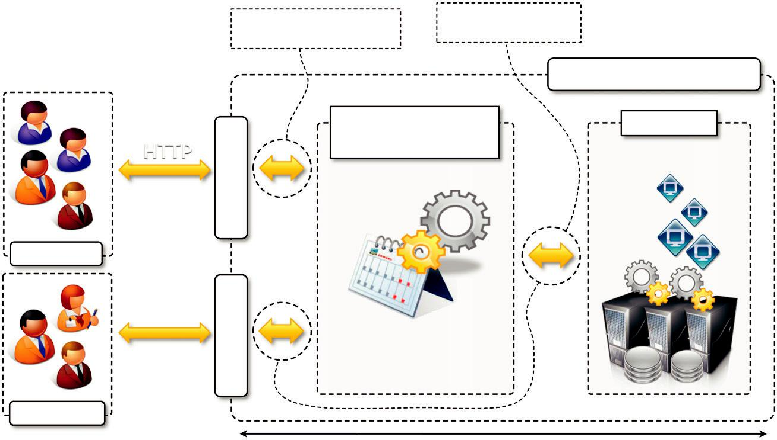

Provider’s Infrastructure

Resource Resources

OCCIInterface | Management Framework

any channel,
any protocol

Other Clients

Provider’s APIs

Most interoperable Least interoperable

FIGURE 11.8

OCCI reference scenario.

These components can be used to represent any services offered by any IaaS provider and can describe their behavior and properties.

A practical implementation of an OCCI model is then made accessible through RESTful inter-faces over HTTP. The OCCI rendering model specification (GFD.185 OCCI HTTP Rendering¹⁷) defines how the model can be transmitted and serialized through HTTP. Therefore, a cloud resource provider has to implement the following two steps in order to be OCCI compliant:

Define the services and resources it offers, according to the OCCI core model.

Provide a RESTful interface that allows clients to discover the set of resources it exposes according to the OCCI HTTP rendering model.

If the cloud vendor is an IaaS provider, the OCCI Infrastructure document constitutes a starting point from which the vendor develops its own representation.

Currently, the Open Cloud Computing Interface provides linking with several technologies for building cloud computing services, principally within the IaaS market segment. Various open-source initiatives (jCloud, libvirt, OpenNebula, and OpenStack), research projects (RESERVOIR, Big Grid, Morfeo Claudia, Emotive), and consortia (SLA@SOI) are offering OCCI interfaces to their services. Initially developed as a joint effort of Sun Microsystems, Rabbit MQ, and the Univesidad Complutense de Madrid, now OCCI involves more than 250 organizations in both aca-demia and industry, such as Rackspace, Oracle, GoGrid, and Flexiscale. Because of such strong support, OCCI is a promising step toward the definition of cloud interoperability standards for a cloud federation scenario.

Cloud data management interface

The Cloud Data Management Interface (CDMI) [136] is a specification for a functional interface that applications will use to create, retrieve, update, and delete data elements from the cloud. This interface also provides facilities for discovering the properties of a given cloud storage offering. CDMI has been proposed by the Cloud Storage Technical Working Group of the Storage Network Industry Association (SNIA), an association promoting standards in the management of IT informa-tion with a particular focus on data storage. SNIA has also produced a reference implementation of the CDMI, thus facilitating the process of quickly producing a working standard by means of feed-back from the community.

The specification introduces and defines the concept of cloud storage as a “delivery of virtua-lized storage on demand,” also known as Data storage-as-a-Service (DaaS). The main concept of DaaS is to abstract data storage behind a set of interfaces and to make it available on demand. This definition encloses a considerably wide range of storage architectures. Figure 11.9 provides the overall context in which cloud storage interfaces will operate. A cloud data management ser-vice provides a CDMI made available to clients through RESTful interfaces. Such an interface provides access to information, data, and storage services that can be leveraged to access storage clouds. These can eventually rely on several different technologies to implement data and storage services.

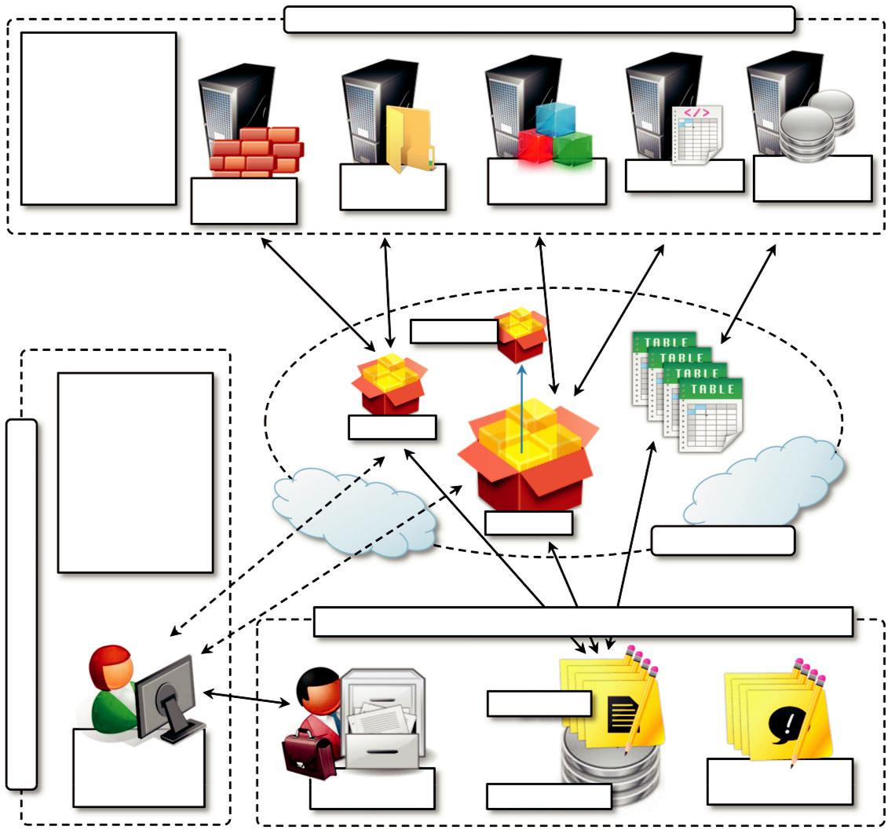

Clients Acting in the Role of Using Data Storage Interface

Clients can be in the

Cloud or Enterprise

and provide

additional services

(data,

computing, etc…)

 | File System | Object Storage | XAM Client | Database /
 | File System | Object Storage | XAM Client | Table Client
Block Storage | Client | Client |  | Table Client
Client

Export Data to the Cloud | POSIX (NFS, | CDMI
 | CIFS, WebDAV) | CDMI
iSCSI, FC, FCoE,
LUNs, Targets | Container

Multiple,

Proprietary

Interfaces

Clients Acting in the Role of Managing Data / Storage

Container
Management of the

Cloud Storage can be
standalone or part of
the overall
management of your
Cloud Computing |  | Container
 |  |  | Data Storage Cloud
 | Draw Resources on Demand
 |  | Storage Cloud Data Management Interface (CDMI)
 |  | Data Services
Data Storage
Management | Cloud Data |  | Information
Client | Cloud Data |  | Services (Future)
Client | Management | Storage Services | Services (Future)

FIGURE 11.9

Cloud storage reference model.

The interface exposes an object model that allows clients to manipulate and discover data components. The object model contains the following components:

Data objects. These are the fundamental storage component in CDMI and are analogous to file in a file system. Data objects can have a set of well-defined single-value fields. In addition, they can support metadata used to describe the object, which can be provided by either the storage system or the client.

Container objects. Container objects are the fundamental abstraction used to group stored data. A container may have zero or more child objects and a set of well-defined fields. As happens

for data objects, containers support metadata as well. Containers support nesting, and a child container inherits all the data system metadata from its parent.

Domain objects. Domain objects are quite similar to container objects and they are used to represent administrative ownership stored within a CDMI storage system. As containers, they support nesting and facilitate the flow of information upward since an aggregate view of data is useful for administrative purposes.

Queue objects. Queues are a special class of containers that are used to provide first-in, first-out (FIFO) access when storing and retrieving data. Queues are useful to support writer-reader and producer-consumer patterns for storage data management. A queue always has a parent object from which it inherits the system metadata.

Capability objects. Capability objects are a special class of container object that allow a CDMI client to discover what subset of the CDMI standard is implemented by a CDMI provider. Capabilities are descriptors of the set of interactions that the system is capable of performing against the URI to which they are attached. Each entity defined in the object model is expected to have a field that represents the URI from which the capabilities for that object can be retrieved. Every CDMI-compliant interface must be able to list the capabilities for each given object, but support for all the capabilities listed in the standard is optional.

Using the simple operation defined by REST, clients can discover and manipulate these objects by creating, retrieving, updating, and deleting objects (CRUD: Create, Retrieve, Update, and Delete). The set of operations that are supported is defined by the capabilities attached to each entity. Besides the fundamental operations allowed by REST, the CDMI also provides support for snapshots, seriali-zation and deserialization, logging, and interoperation compared to other protocols and standards.

The CDMI was initially proposed in 2010 and collected consensus from several other bodies involved in the standardization of cloud computing technologies and was included in roadmaps and studies. Currently, SNIA is moving toward transforming CDMI into a de jure standard by interoper-ating with the major standardization organizations, such as ISO/IEC and INCITS.¹⁸

Cloud security alliance

The Cloud Security Alliance (CSA) is nonprofit organization with the mission of promoting the use of best practices for providing security assurance in cloud computing and education on the use of cloud computing to help secure all other forms of computing. Rather than acting as a standardizing body, CSA offers a context in which to discuss security practices and provide guidance for devel-oping reliable and secure cloud computing systems.

The most relevant initiative of the CSA has been the Cloud Controls Matrix (CCM). The matrix is specifically designed to provide fundamental security principles for guiding cloud vendors and for assisting prospective cloud service consumers in assessing the overall risks implied in leverag-ing a cloud service provider. This document was prepared by taking into account the most impor-tant security standards, regulations, and control frameworks, such as ISO 27001/27002, ISACA COBIT, PCI, and NIST. The CCM strengthens existing information security control environments

within a cloud computing context and provides a way to align the security practices that should be adopted in the cloud with those that already exist in other domains.

The CCM’s relevance in a cloud federation scenario is quite evident. It provides a standardized way to assess the security measures put in place by each cloud service provider and helps define a minimum-security profile within a cloud federated scenario, thus increasing the trust in the concept of federation.

Other initiatives

Besides the major standardization efforts, many initiatives have obtained minor popularity, are endorsed by specific organizations, or are related to the use of cloud computing in a very specific context. Among the most relevant are these:

National Institute of Standards and Technologies (NIST). As discussed in Chapter 4, NIST proposed a working definition of cloud computing that is now widely accepted. Another important initiative is the Standards Acceleration to Jumpstart Adoption of Cloud Computing (SAJACC). This initiative’s activities are mostly related to the assessment of existing standards in cloud computing, to actively contributing to the creation of open standards, and to the identification of gaps within existing standards.

Cloud Computing Interoperability Forum (CCIF). This industry forum was initially supported by several players in the field of cloud computing and was formed to enable a global cloud computing ecosystem whereby organizations can seamlessly operate together to foster wider

adoption of the technology. The activity of the forum is limited to one single event in 2009 and led to the proposal of the Unified Cloud Interface (UCI),¹⁹ which is an attempt to provide a unified interface to the various APIs exposed by different vendors. Functional implementations exist for Amazon EC2 and Enomaly ECP.

Open Cloud Consortium (OCC). This not-for-profit organization manages cloud computing infrastructures to support scientific research. It also develops reference implementations, benchmarks, and standards for cloud technologies.

Global Inter-Cloud Technology Forum (GICTF). The GICTF is a Japanese organization whose aim is to bring together the knowledge developed by industry, academia, and government and to support research and development feasibility tests on the technologies related to cloud interoperability. More precisely, the forum focuses on the standardization of the network protocols that enable interoperation among clouds and of the interfaces through which this interoperation happens.

Cloud Work Group. This initiative of the Open Group is aimed at creating a common understanding between buyers and suppliers as to how enterprises of all sizes and scales can leverage cloud computing technologies. The group has established several activities to enhance business understanding, analysis, and uptake of cloud computing technologies.

Several other initiatives exist. They cover the creation of standards and specifications for areas of cloud computing, which are not strictly related to supporting the interoperation among different cloud service providers but still constitute a step toward the development of supporting

technologies for a cloud federation scenario that is based on the definition of the rules, policies, and a model for a cloud federation.

Security

Cloud computing supports the development of elastically scalable systems by leveraging large computing infrastructures that eventually host applications, services, and data. In this scenario, security arrangements constitute a fundamental requirement that cannot be overlooked. Security management becomes even more complex in the case of a cloud federation, where confidential information is dynamically moved across several cloud computing vendors.

One of the first questions that should be asked is whether the cloud vendors offer enough transpar-ency to implement the security management process required to protect your data and applications. Implementing and deploying the required security infrastructure is important to understanding the responsibilities of those who offer cloud computing services and of those who use them. Cloud com-puting is a new territory for security; compared to managed services providers, where the management of security infrastructure is completely handled by the service provider, in a cloud deployment security management is divided between the provider and the customer. The responsibilities of the two parties change according to the type of service offering. IaaS vendors are required to provide basic security in terms of auditing and logging of access to virtual machine instances or cloud storage. PaaS vendors are expected to offer a secure development platform and a runtime environment for applications. SaaS vendors have the major responsibilities in terms of security, since they have to build a secure computing stack (infrastructure, platform, and applications) that users customize for their needs.

Despite the novelty introduced by cloud computing, it is possible to consider existing security fra-meworks and practices as a starting point for securely running applications and systems. In particular, the standard ISO/IEC 27001/27002 and the Information Technology Infrastructure Library (ITIL) ser-vice management framework are industry standards that provide guidance in terms of security manage-ment processes and practices. ITIL is a set of guidelines that define a security framework in terms of policies, processes, procedures, and work instructions. ITIL is not a standard, and therefore organiza-tions and management systems cannot be certified “ITIL-compliant.” Despite this fact, these guidelines constitute a reference model for implementing security measures. ISO/IEC 27001/27002 formally define the mandatory requirements for an information security management system and provide guidelines for the security controls to implement within a security system. In short, these standards help organizations ensure that the current security levels are appropriate to their needs and to implement security.

Key elements in management of security in a cloud scenario have been identified as the following [156]:

Availability management (ITIL)

Access control (ISO/IEC 27002, ITIL)

Vulnerability management (ISO/IEC 27002)

Patch management (ITIL)

Configuration management (ITIL)

Incident response (ISO/IEC 27002)

System use and access monitoring (ISO/IEC 27002)

Put together, these elements can compose a reference security framework for cloud computing systems. They invest all the layers of the cloud computing reference model and are differently supported across the market segments characterizing cloud computing.


Table 11.2 Customer Responsibilities for Security Management in the Cloud [156]

Activities | IaaS | PaaS |  | SaaS
Availability | Manage VM availability with | Manage this activity for | Provider responsibility
management | fault-tolerant architecture | applications deployed in the
 |  | PaaS platform (the provider is
 |  | responsible for runtime engine
 |  | and services)
Patch and | Manage VM image hardening | Manage this activity for | Provider responsibility
configuration | Harden your VMs, applications, | applications deployed in the
management | and database using your | PaaS platform
 | established security hardening | Test your applications for
 | process | OWASP Top 10 vulnerabilities²⁰
 | Manage activities for your VMs,
 | database, and applications
 | using your established security
 | management process
Vulnerability | Manage OS, applications, and | Manage this activity for | Provider responsibility
management | database vulnerabilities | applications deployed in the | Manage user
Access control | leveraging your established | PaaS platform (the provider is | provisioning
management | vulnerability management | responsible for their runtime | Restrict user access
 | process | engine and service) | using authentication
 | Manage network and user | Manage developer access to | methods (user- and
 | access control to VMs, secure | provisioning | network-based
 | privileged access to | Restrict access using | controls)
 | management consoles, install | authentication methods (user- | Federate identity and
 | host Intrusion Detection System | and network-based controls) | enable SSO if SAML is
 | (IDS), and manage host firewall | Federate identity and enable | supported
 | policies | SSO if SAML²¹ is supported

An overall view of the security aspects and how they are addressed by cloud vendors at three different levels (IaaS, PaaS, and SaaS) is shown in Table 11.2. A good starting point in identifying a customer’s security responsibilities and planning the appropriate measures is the service contract made with the provider. This contract clearly defines the scope of action of the provider and the warranties given to the customers. Moreover, cloud providers’ APIs and services help in managing security and accountability. Cloud providers offer service dashboards that could be usefully inte-grated into the organization’s internal management processes and tools. Currently, the missing bit

from a security point of view is the lack of enterprise-grade access for managing the security of cloud computing systems where system administrators can have a holistic view of the security defined for cloud computing applications.

Cloud federation security

Cloud federation introduces additional issues that have to be addressed in order to provide a secure environment in which to move applications and services among a collection of federated providers. Baseline security needs to be guaranteed across all cloud vendors that are part of the federation.

An interesting aspect is represented by the management of the digital identity across diverse organizations, security domains, and application platforms. In particular, the term federated identity management refers to standards-based approaches for handling authentication, single sign-on (SSO), role-based access control, and session management in a federated environment [157]. This enables users to utilize services more effectively in a federated context by providing their authenti-cation details only once to log into a network composed of several entities involved in a transac-tion. This capability is realized by either relying on open industry standards or openly published specifications (Liberty Alliance Identity Federation, OASIS Security Assertion Markup Language, and WS-Federation) such that interoperation can be achieved. No matter the specific protocol and framework, two main approaches can be considered:

Centralized federation model. This is the approach taken by several identity federation standards. It distinguishes two operational roles in an SSO transaction: the identity provider and the service provider.

Claim-based model. This approach addresses the problem of user authentication from a different perspective and requires users to provide claims answering who they are and what they can do in order to access content or complete a transaction.

The first model is currently used today; the second constitutes a future vision for identity management in the cloud.

Digital identity management constitutes a fundamental aspect of security management in a cloud federation. To transparently perform operations across different administrative domains, it is of mandatory importance to have a robust framework for authentication and authorization, and fed-erated identity management addresses this issue. Our previous considerations of security contribute to design and implement a secure system comprising the cloud vendor stack and the user applica-tion; federated identity management allows us to tie together the computing stacks of different vendors and present them as a single environment to users from a security point of view.

Legal issues

Besides the technical complexities required to make cloud computing happen, legal issues related to access rights, privacy, and control are peculiar to cloud computing. This section provides an overview of this topic and discusses the potential legal implications of a cloud federation scenario.

Enterprises and end users leveraging cloud computing relegate the control of systems, applica-tions, or personal data to third parties. This is not much different from normal outsourcing prac-tices, which have been widely in precedence. Also, a considerable similarity to application service

providers (ASPs) can be found. If we compare cloud computing with traditional outsourcing and

ASP service delivery, we can observe that [140]:

Outsourcing arrangements generally cover an entire business or IT process of a business organization, and they are geared toward running the business for the benefit of the customer. The software generally belongs to the customer, and it is deployed and managed on the customer’s equipment. Moreover, arrangements are highly negotiable and defined by long and complex contracts.

The ASP model constitutes an early implementation of the SaaS delivery model, which does not imply any sort of scalability on demand. In this scenario the provider owns the software and the hardware, which might be located in several locations but are statically known a priori. Arrangements are negotiable but not as complex as those regulating outsourcing.

Cloud computing covers multiple service models: software, infrastructure, and runtime platforms. Arrangements between consumers and providers are quite limited and mostly based on a pay-per-use model, which is metered according to appropriate units (time, bandwidth, storage size, or transactions). Economics of performance drive the activity of the provider, which may choose to locate, or relocate, applications and systems in order to minimize costs and improve efficiency. Moreover, providers may have multiple datacenters located sparsely, either to better serve a wide variety of customers or to exploit advantageous environment conditions.

What makes cloud computing different from traditional approaches is the global scale at which providers operate and deliver services. The need to serve a potentially massive number of custo-mers makes providers look for solutions that guarantee optimal service delivery and low operational costs. Therefore, having a sparse infrastructure, normally spanning several countries, is quite com-mon. Second, because cloud computing delivers IT services as utilities, the dynamics of service lease and consumption make the common arrangements unsuitable for commercial use. As a result, multiple service-contracting models have been introduced: licensing, service agreements, and online agreements.

This new scenario makes more complicated the legal management of existing issues and intro-duces new ones. For instance, a disperse geography of datacenters makes it harder to guarantee confidentiality and privacy of data, especially when data are located in different countries with dif-ferent jurisdictions. There already are laws and regulations for management of sensitive informa-tion, but the heterogeneous context in which cloud computing services are delivered requires a different approach from a legal perspective. Moreover, the dynamics of contracts between service consumers and providers introduce new challenges; arrangements need to be more flexible and can-not be defined by lengthy contracts obtained by complex negotiations. As we have seen, vendor lock-in is a sensitive issue in cloud computing; what will then happen when a provider files for bankruptcy or gets acquired by another provider? Will the previous SLAs still be honored? What are the warranties for customers with respect to this situation? Furthermore, service providers might stipulate agreements between themselves, which leads to a definitely more complex management of customers’ sensitive data. For instance, customers do not generally have control over where the ser-vice they are leasing operates; in a federated scenario, a service might offered by a different pro-vider from the one the customer has stipulated in the SLA. In such a case, what are the warranties offered by the other provider in terms of confidentiality, secrecy, integrity, and data retention?

We can categorize the wide range of legal issues that are connected with cloud computing in the following three major areas: privacy, security, and intellectual property; business and commer-cial; and legislation and jurisdiction. As happens for any disruptive technology, there is always a lag between the regulations that govern the interaction within parties and the new opportunities and approaches that such technology brings. In the case of cloud computing, the law lags behind the technology innovation, even though several initiatives are now taking place.

Privacy, security, and intellectual property related issues

This category includes all the legal issues arising from the management of data, applications, and services by the cloud service provider on behalf of the customer as part of its service offering. As previously noted, cloud computing implies the relegation of control over data and applications to third parties. To provide customers with a reliable and commercially viable service, cloud com-puting providers are expected to implement appropriate procedures to protect the integrity of data, data secrecy, and the privacy of users. In this scenario, different pieces of legislation apply, which sometimes may also be conflicting.

The legislation concerning privacy and security of data is perhaps the most developed. This is because it does not only apply to cloud computing-based systems. Again, different countries, and different states within the same country, have different approaches and advancement stages. The United States has a considerable amount of legislation regulating privacy and security mea-sures; these laws also apply to cloud computing. An important U.S. player is the Federal Trade Commission (FTC), which is in charge of conducting investigations to assess the liability of any organization that provides financial services or that engages in a commercial activity aimed at sell-ing products if that organization breaks security and privacy regulations. In particular, data breach, protection, and accessibility are objects of current legislation:

Data breach, or loss of unencrypted electronically stored information, is a very sensitive matter. Avoiding data breach is important for both cloud services consumers and providers. The former have a direct loss caused by the potential misuse of sensitive information from third parties

(stolen Social Security numbers, misuse of credit cards, and access to personal medical data or financial statements). The latter are damaged because of financial harm, potential lawsuits, damage to reputation, FTC investigations, and loss of customers. Therefore there is interest on both sides to embrace measures that prevent data breach. This is also supported by the legislation: Almost all 50 U.S. states require the affected person to be notified upon the occurrence of data breach. Therefore, cloud providers that have their systems compromised are required to notify the affected persons and coordinate with those who provided such data. Relevant legislation for data breach includes the Health Insurance Portability and Accountability Act (HIPAA) [145] and the Health Information Technology for Economic and Clinical Health (HITECH) Act [144].

Data protection. Other interesting considerations can be made regarding the measures that should be put in place to ensure the confidentiality of personal information. The Gramm-Leach-Bliley (GLB) Act [141] requires that financial institutions implement appropriate procedures to protect personal information and prevent unauthorized access to data. Cloud providers managing sensitive information will then be required to (1) demonstrate that they have deployed appropriate measures for the protection of sensitive data; (2) contractually agree to prevent

unauthorized access; or (3) both. Under the GLB Act, the FTC requires that all businesses significantly involved in the provision of financial services and product have a written security plan to protect information related to customers (Safeguards Rules [142]). Another important protection measure is represented by the Red Flag Rules [143], which force financial institutions to monitor and block suspicious activities that potentially might represent evidence of identity theft. Organizations need to have documented policies describing the measures they take to prevent identity theft.

Data access. Legal issues also arise when it comes to determining who, besides their respective owners, can have access to sensitive data. The U.S. legislation has a considerably aggressive approach with respect to this issue. The USA PATRIOT Act [146] confers the right to any organization operating on behalf of the U.S. government to gain access to personal financial information and student information stored in electronic systems without any suspicion of wrongdoing of the person whose information it seeks. The act requires the organization to prevent a government’s certification that the information accessed can be relevant to an ongoing criminal investigation. The institution holding the financial information might be prevented from informing their clients about governmental access to their data. The power conferred by this act puts a cloud provider in the difficult position of being required to provide sensitive information without giving notice to the respective user.

Other countries and interstate organizations have different approaches. The European Union (EU) in 1995 passed the European Union Directive on the Protection of Individuals with Regard to the Processing of Personal Data and Movement of Such Data Privacy Directive. The directive states that countries belonging to the EU must pass a data protection law covering both government and private entities that process business and consumer data. Furthermore, the directive mandates that any geography to which EU personal data are sent must have a level of data protection as mea-sured by EU standards. This directly impacts on the possibility for many cloud providers entering and operating lawfully in the EU. Therefore, the possibility of conducting business in the European Union must be carefully studied.

Besides the EU, many other countries have passed legislation protecting privacy and security of data. Argentina has an approach similar to that of the EU. Hong Kong has a Personal Data Ordinance [148] that covers both public and private data processors of either electronic or non-electronic documents. Other countries, like Brazil, express the constitutional right to privacy but do not have a comprehensive law on the subject. A different approach is taken by Canada, which has an organization-to-organization approach. The Personal Information Protection and Electronic Document Act (PIPEDA) [149] regulates the level of protection for personal data whenever inter-acting with a Canadian-based company, regardless of its geographical location. In brief, Canadian organizations are held accountable for the protection of personal information they transfer to third parties, whether such parties are inside or outside Canada. All these different regulations are not only a source of international conflicts of law but also identify the immature state of legal support with regard to the globalization of computing utilities trading.

Another element of concern that directly relates to the way sensitive information is handled in the cloud is the management of intellectual property (IP) rights. It is important in this case not to protect the data from entities external to the cloud service provider but to ensure the IP attached to the data, or generated by applications, that is hosted in the cloud still belongs to the user of the cloud. This is

generally the rule of thumb that applies for the protection of IP rights, which needs to be enforced by appropriate contractual terms between the service consumer and the service provider. This is particu-larly important in case cloud service providers file for bankruptcy and the hosted IP is used to augment the value of the company, thus facilitating the provider’s exit from bankruptcy.

Business and commerce-related issues

Legal issues can also arise as a result of specific contractual terms and arrangements between the cloud provider and the user. Contractual terms need to be able to deal with issues such as:

What is defined as a service that is agreed between the two parties?

What is the liability of each of the parties?

What risk are users running while relying on a given provider?

What are measures that are put in place to guarantee users access to their data?

The first types of legal issues we can consider are contractual ones. These relate to the specific nature of the agreement between the cloud provider and the consumer. Licensing agreements, the most used form of contractual agreement for software before the spread of SOA, are no longer applicable. Service agreements are a more appropriate form for settling arrangements in a cloud computing scenario, since there is no real transmission of a software artifact from the contracting entities and since IT services are offered and priced as utilities. In any market segment of cloud computing (Iaas, Paas, or SaaS), the control and access points are offered by the cloud provider and the agreement covers all the basic terms and conditions of use of the service, with clear specifi-cation of provider liabilities in case of service interruption. Generally, users have very limited options and the contractual terms are in the form of online agreements that the user cannot negoti-ate. Since this is the only documents that binds the two entities, it is really important to have a clear specification of the privacy policy adopted by the provider and the compliance of such policies with the current laws on the subject. It is also important to verify what will be the provider’s liabil-ity in case of data breach. In most cases, providers have a very limited liability and compensate users with service credit in the best cases. Since these terms are not negotiable, the service agree-ment is of use to the consumer in carefully evaluating whether to sign an agreement with the pro-vider. As more enterprises and mission-critical applications move to the cloud, a more robust and balanced contractual form is needed.

Some business and commercial considerations may also influence the contractual arrangements between providers and consumers. For instance, measures aimed at minimizing the consumer’s, considerations about the provider’s viability, and the future availability of the data stored in the cloud are all element of concern. These issues must be referenced in the agreement. Elements that contribute to minimizing the risk are measures aimed at protecting the integrity of data, specific SLAs indicating the guaranteed percentage of availability of the service outside scheduled outages, and disaster-recovery measures. The provider’s viability is another aspect that contributes to the final decision to enter an agreement with a given provider. Since vendor lock-in is still a reality, the ability of the provider’s business to survive is fundamental also because source-code escrow²² does not help in this scenario. The risk of bankruptcy is not the only menace that could prevent

durable and continuous access to data and applications in the future. Other conditions include ter-mination of the provider’s business activity or provider acquisition by another company. In these cases, the SLA with the customer should clearly specify which policies are in place to guarantee durable access to customer data.

Jurisdictional and procedural issues

Jurisdictional and procedural legal issues arise from two major aspects of cloud computing: the geo-location of data and applications served by cloud providers and the laws and regulations that are applied in case of litigation.

Jurisdictional issues are mostly related to location of data and the specific laws that apply in that location. Cloud service providers locate their datacenters in order to reduce their operational costs. The placement of datacenters is influenced by the desire to optimally serve customers on a global scale. For this reason it is quite common to distribute the infrastructure of a single cloud provider over the globe. Specific issues arise from the different laws that are applied for the protection of data. For instance, the EU directive states that any personal data generated within the European Union are subject to European law as well as concerning the export of these data to a third-party country. This limits the mobility of data among datacenters located in different countries, if an appropriate level of data protection is not guaranteed. Furthermore, SLAs are agreed to within a context defined by a spe-cific governing law, but due to the mobility of data, such laws might not be effective and could fail in their purpose of protecting customer rights. The condition is even worse when there is no specific statement indicating the governing law under which the agreement was signed.

Jurisdictional issues may also arise in the case of subcontracting. This is a quite common sce-nario in the case of cloud federation: A cloud provider leverages other providers’ services and facil-ities to provide services to customers. This is mostly done transparently to the user. In case of failure in service delivery, it will be difficult for the cloud user to identity the real causes. In this case, the scenario is complicated by the fact that, besides different geographies, different organiza-tions are involved in delivering the service to the end user.

Different jurisdictions lead to what is also called the conflict of laws, which acknowledges the fact that laws of different countries may operate in opposition to each other, even if they relate to the same subject matter. The general rule of thumb is that, since each nation is sovereign within its own territory, the laws of a country will affect all the people and property within it, including con-tracts made and actions carried out within its borders. As already observed, the SLA should clearly specify the governing law as well as the other potential jurisdictions that may be involved in deliv-ering the service to the end user.

Besides jurisdictional issues, there are other important aspects concerning the application of the law in case of litigation, which is the process of bringing a legal dispute to a court. In this context, one party might require the other party to provide evidence of data in terms of electronic docu-ments (emails, reports, financial records, etc.). This process is also known as ediscovery and poses an interesting challenge in the case of cloud computing, where control over data and systems is rel-egated to third parties. Failing to comply with an ediscovery process because of lack electronically stored information is not an option and in most cases will result in several charges.

Traditionally, enterprises organized staff and internal procedures to respond to an ediscovery process with the required information. In a scenario where an enterprise leverages cloud providers, there is no infrastructure nor staff that directly manages such activities; instead, the maintenance of

data and its accessibility are all offloaded to the cloud provider. Therefore, the challenges concern the storage and retrieval of sensitive data over the long term. Since storage is normally billed and has an operational cost in the cloud, this may pose an additional burden to enterprises that want to leverage the cloud. Second, access to data despite the survival of the provider’s business activity is another element of concern with regard to ediscovery.

Implications in a cloud federation scenario

In this section we have mostly discussed the nature of the legal issues that may arise in leveraging cloud computing solutions, from the perspective of the interaction between cloud service consumers and providers. How do these issues impact a cloud federation scenario? And are there other elements to consider from a legal perspective?

We can observe that interactions among different cloud providers can occur in the form of sub-contracting, which has been discussed, or as a normal interaction between a consumer and a provider, where the role of the consumer is played by another cloud provider. Therefore, all the legal issues introduced previously apply. As noted, the case in which services offered by different providers are composed together to deliver the final service to the cloud user poses additional com-plications. This is because the contractual interaction may spawn over heterogeneous geographies and necessarily involve different organizations. Hopefully, the creation of a federation will help define a better body of laws that are compliant with all the legislation of the countries involved in possible transactions among cloud providers and users and uniform across all the federation.

Technologies for cloud federations

Even though the concept of cloud federation or the InterCloud is still immature, there are some supporting technologies that enable the deployment of interoperable clouds, at least from an opera-tional point of view. These initiatives mostly originated within academia and principally focus on supporting interoperability among different IaaS implementations, with a limited implementation of the capabilities defined at the logical level.

Reservoir

Resources and Services Virtualization Without Barriers, or RESERVOIR [155], is a European research project focused on developing an architecture that supports providers of cloud infrastruc-tures to dynamically partner with each other to extend their capabilities while preserving their administrative autonomy. RESERVOIR defines a software stack enabling interoperation at the IaaS layer and providing support for SLA-based execution of applications on top of the infrastructure overlay that results from the federation of infrastructure providers.

RESERVOIR is based on the concept of dynamic federation: Each infrastructure provider is an autonomous business with its own business goals and that might decide to partner with other busi-nesses when needed. The federation is obtained by means of the RESERVOIR middleware that needs to be deployed at each site. The IT management at a specific site is fully autonomous and dictated to by policies that depend on the site’s business goals. When needed, internal IT resources are leased to other providers within the context of a negotiated SLA. The role of RESERVOIR is to orchestrate this process and to minimize the barriers obstructing interoperation among different administrative domains.
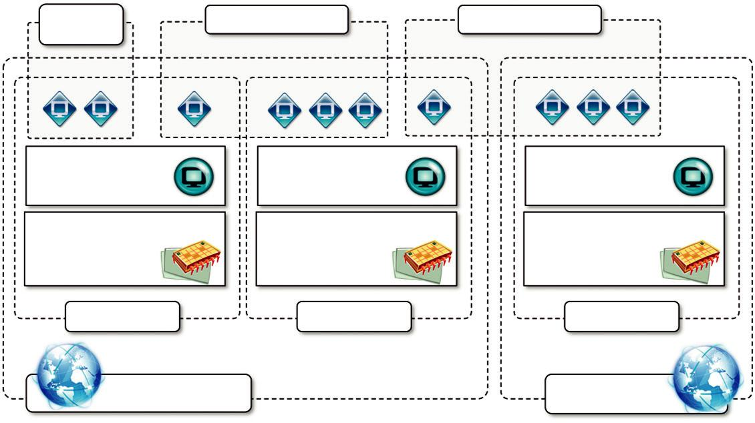

^{Service} Service Application 2 Service Application 3

Application 1

Virtualizer Virtualizer Virtualizer

Computational Resource Computational Resource Computational Resource

VEE Host

VEE Host

VEE Host

RESERVOIR Site 1

RESERVOIR Site 2

FIGURE 11.10

RESERVOIR cloud deployment.

Figure 11.10 provides a general overview of a RESERVOIR cloud. The framework defines an infrastructure overlay that spans multiple administrative domains and different geographic locations. Each site runs the RESERVOIR software stack and provides an on-demand execution environment in which components of a service application can be deployed and executed. The model introduces a clear separation between service providers and infrastructure providers. Service providers are the enti-ties that understand the needs of a particular business and offer service applications to address those needs; they do not own infrastructure but rather lease it from infrastructure providers. Infrastructure providers operate RESERVOIR sites and offer a virtually infinite pool of computational, network, and storage resources. Service providers define service applications that are modeled as a collection of components that can be deployed over a distributed virtual infrastructure, which can be either explicitly or implicitly provisioned. In the first case, the service provider conducts sizing and capacity-planning studies to identify the appropriate number of components to be required for a given workload condition. The specification is obtained by means of minimal service configuration and a set of elasticity rules that are used by RESERVOIR to dynamically provision resources under varying workload conditions. In the second case, the service provider provides neither a minimal service con-figuration nor elasticity rules. The sizing is automatically made by the RESERVOIR middleware, which tries to minimize overprovisioning. Service providers are billed on a pay-as-you-go model and can ask for usage reports to verify the billing.

Service application components are represented as virtual packages, which also specify execu-tion environment requirements. Infrastructure providers can leverage any virtualization technology

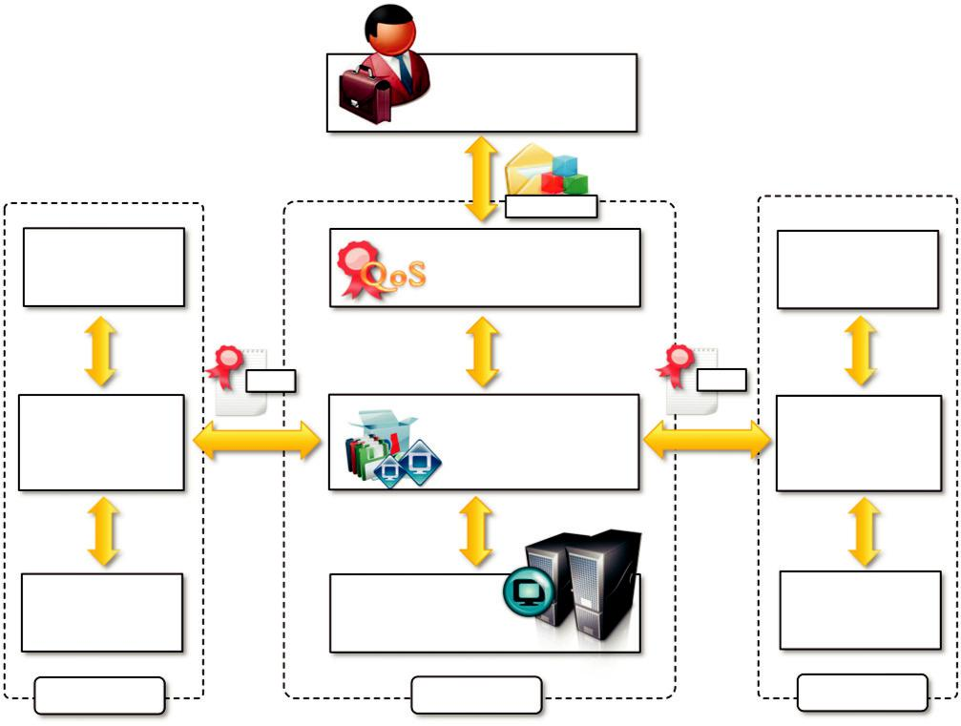

 | Service Provider
 | manifest
Service | Service Manager | Service
Manager | Service Manager | Manager
SLA |  | SLA
VEE Manager | VEE Manager | VEE Manager
(VEEM) | (VEEM) | (VEEM)
VEE Hosts | VEE Hosts (e.g. | VEE Hosts
VEE Hosts | hypervisor, VJSC Host, …) | VEE Hosts
Site A | Site B | Site C
FIGURE 11.11
RESERVOIR architecture.

of choice and are in charge of providing the required environment for such applications. An impor-tant element for determining the virtual environment for service applications is the service manifest. This is one of the key elements of the RESERVOIR model and specifies the structure of the service applications in terms of component types that are to be deployed as virtual execution environments (VEEs). The service manifest contains a reference to a master image, which is a self-contained soft-ware stack (OS, middleware, applications, data, and configuration) that fully captures the function-ality of the component type. Additional information and rules specify how many instances to deploy and how to dynamically grow and shrink their number. Moreover, the manifest also speci-fies the grouping of components into virtual networks and/or tiers that form the service applica-tions. The manifest is expressed by extending the Open Virtualization Format to simplify interoperability and leverage an already existing popular standard.

Figure 11.11 describes the internal architecture of a RESERVOIR site that enables the federated and SLA-based execution of applications. The RESERVOIR stack consists of three major components:

Service Manager. The Service Manager is the highest level of abstraction and constitutes the front-end used by service providers to submit service manifests, negotiate pricing, and monitor

applications. This component deploys and provisions VEEs according to the service manifest and monitors and enforces SLA compliance by controlling the capacity of a service application.

Virtual Execution Environment (VEE) Manager. This component is the core of the RESERVOIR middleware and is responsible for the optimal placement of VEEs into VEE hosts according to the constraints expressed by the Service Manager. Moreover, the VEE Manager also interacts with VEE Managers in other sites to provision additional instances for the execution of service applications or move VEEs to other sites in case of overload. This component realizes the cloud federation.

VEE Host (VEEH). This is the lowest level of abstraction and interacts with the VEE Manager to put into practice the IT management decisions regarding heterogeneous sets of virtualization platforms. This level is also in charge of ensuring appropriate and isolated networking among VEEs that belong to the same application. The VEEH encapsulates all platform-specific management that is required to expose the used virtualization technology through a standardized interface to the VEE Manager.

Each of these components adopts a standardized interface and protocol to interoperate with the adjacent layer. This design decision was made to promote a variety of innovative approaches at each layer. It offers infrastructure providers the freedom to integrate the RESERVOIR middleware with their own existing technology.

InterCloud

InterCloud is a service-oriented architectural framework for cloud federation that supports utility-driven interconnection of clouds. It is composed of a set of decoupled elements that interact via a market-oriented system to enable trading of cloud assets such as computing power, storage, and execution of applications. As depicted in Figure 11.12, the InterCloud model comprises two main elements: CloudExchange and CloudCoordinator:

CloudExchange. This is the market-making component of the architecture. It offers services that allow providers to find each other in order to directly trade cloud assets, as well as allowing parties to register and run auctions. In the former case, CloudExchange acts as a directory service for the federation. In the latter case, it runs the auction. For offering such services to the federation, CloudExchange implements a Web service-based interface that allows datacenters to join and leave the federation; to publish resources they want to sell; to register their resource requirements so that parties interested in selling providers are able to locate potential buyers for their resources; to query resource offers that match specific requirements; to query requirements that match available resources from a party; to withdraw offers and requests from the coordinator; to offer resources in auctions; to register bids; and to consult the status of a running auction.

CloudCoordinator. This component manages domain-specific issues related to the federation. This component is present on each party that wants join the federation. CloudCoordinator has front-end components (i.e., elements that interact with the federation) as well as back-end components (i.e., components that interact with the associated datacenter). Front-end components interact with the CloudExchange and with other coordinators. The former allows datacenters to announce their offers and requirements, whereas the latter allows the Coordinator to learn about the current state of the datacenter to decide whether actions from the federation

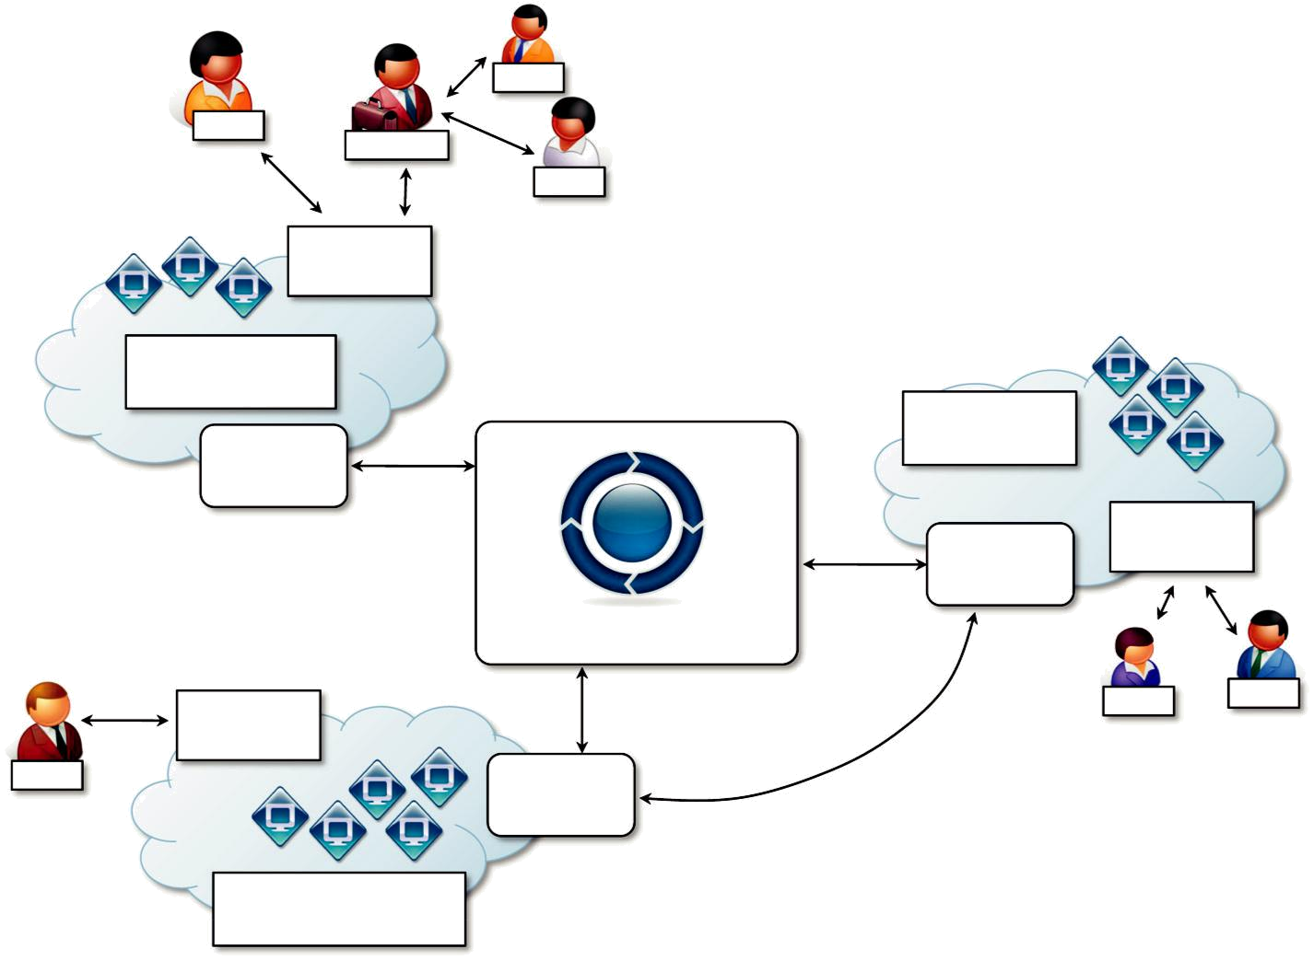

User

User

Broker

User

User

Interface

VM Manager

(e.g. Eucalyptus)

Cloud

Coordinator

Cloud Exchange

Publish / Query
User
Offers / Request
Interface

^{User} Cloud Coordinator

VM Manager

(e.g. Open Nebula)

VM Manager

(e.g. EC2)

User

Cloud Interface

Coordinator

_{User} User

Resource

Negotiation

FIGURE 11.12

InterCloud architecture.

are required or not. Therefore, wherever the Coordinator detects that extra resources are required by the datacenter, it triggers the process of discovery of potential providers (by interacting with the cloud federation). Once potential providers are discovered and the preferred one is selected, the Coordinator contacts the remote Coordinator and negotiates. Similarly, when the Coordinator detects that local resources are underutilized, they can publish an offer for resources in the CloudExchange or they can look for matches among requirements registered in the Exchange service.

Negotiation between parties follows the Alternate Offers protocol. The value that each Coordinator is willing to pay for a resource, as well as the value for which each Coordinator wants to sell resources, is not defined by the federation; instead, each Coordinator is free to value resources according to utilization and profit estimation (or any other criteria that a federation mem-ber wants to consider), and they are also free to reject offers that are not attractive for them. This flexibility of providers in deciding how and when to buy or sell resources, how many of them, when, and for what price is a big motivator for providers to join an InterCloud federation. Providers are free to refuse to buy or sell resources if they disagree with the price; similarly, they may opt for using the method that seems more profitable to them (e.g., auction or fixed price).

Moreover, InterCloud acts primarily in the operational layer. That means that issues related to security, VM images, and networking are not handled by the framework. Similarly, providers’ obli-gations and expectations for joining the federation are also not addressed by the framework. Therefore, existing approaches for these layers, or even new solutions for them, can be applied in the InterCloud without changes to its architecture.

Observations

Cloud service providers, which may be competing with each other, need to have clear objectives and incentives for establishing a federation. One primary reason can be to improve the overall QoS perceived by their customers. The second step toward the creation of a federated scenario is the definition of a reference model for the cloud federation, together with a set of rules and policies. This is the level where market-oriented models are adopted and opportunities for renting and leas-ing resources develop. The development and maturity at this stage are still very limited. At a very low level the federation of different cloud vendors is realized through interoperable technologies. This is an area that has seen considerable development, especially concerning the drafting and adoption of standards that support interoperability. We have discussed the most relevant initiatives in this direction and analyzed some reference and prototypal implementations of systems enabling cloud federation at the IaaS level.

Third-party cloud services

One of the key elements of cloud computing is the possibility of composing services that belong to different vendors or integrating them into existing software systems. The service-oriented model, which is the basis of cloud computing, facilitates such an approach and provides the opportunity for developing a new class of services that can be called third-party cloud services. These are the

result of adding value to preexisting cloud computing services, thus providing customers with a dif-ferent and more sophisticated service. Added value can be either created by smartly coordinating existing services or implementing additional features on top of an existing basic service.

Besides this general definition, there is no specific feature that characterizes this class of service. Therefore, in this section, we describe some examples of third-party services.

MetaCDN

MetaCDN [158] provides users with a Content Delivery Network (CDN) [159] [service by leverag-ing and harnessing together heterogeneous storage clouds. It implements a software overlay that coordinates the service offerings of different cloud storage vendors and uses them as distributed elastic storage on which the user content is stored. MetaCDN provides users with the high-level services of a CDN for content distribution and interacts with the low-level interfaces of storage clouds to optimally place the user content in accordance with the expected geography of its demand. By leveraging the cloud as a storage back-end it makes a complex—and generally expensive—content delivery service available to small enterprises.

The architecture of MetaCDN is shown in Figure 11.13. The MetaCDN interface exposes its services through users and applications through the Web; users interact with a portal, while applica-tions take advantage of the programmatic access provided by means of Web services. The main operations of MetaCDN are the creation of deployments over storage clouds and their management. The portal constitutes a more intuitive interface for users with basic requirements, while the Web service provides access to the full capabilities of MetaCDN and allows for more complex and sophisticated deployment.

In particular, four different deployment options can be selected:

Coverage and performance-optimized deployment. In this case MetaCDN will deploy as many replicas as possible to all available locations.

Direct deployment. In this case MetaCDN allows the selection of the deployment regions for the content and will match the selected regions with the supported providers serving those areas.

Cost-optimized deployment. In this case MetaCDN deploys as many replicas in the locations identified by the deployment request. The available storage transfer allowance and budget will be used to deploy the replicas and keep them active for as long as possible.

QoS optimized deployment. In this case MetaCDN selects the providers that can better match the QoS requirements attached to the deployment, such as average response time and throughput from a particular location.

A collection of components coordinate their activities in order to offer the services we described. These constitute the additional value that MetaCDN brings on top of the direct use of storage clouds by the users. Of particular importance are three components: the MetaCDN Manager, the MetaCDN QoS Monitor, and the Load Redirector. The Manager is responsible for ensuring that all the content deployments are meeting the expected QoS. It is supported in this activity by the Monitor, which constantly probes storage providers and monitors data transfers to assess the performance of each provider. Content serving is controlled by the Load Redirector, which is in charge of redirecting user content requests to the most suitable replica given the condi-tion of the systems and the options specified during the deployment. Interactions with storage
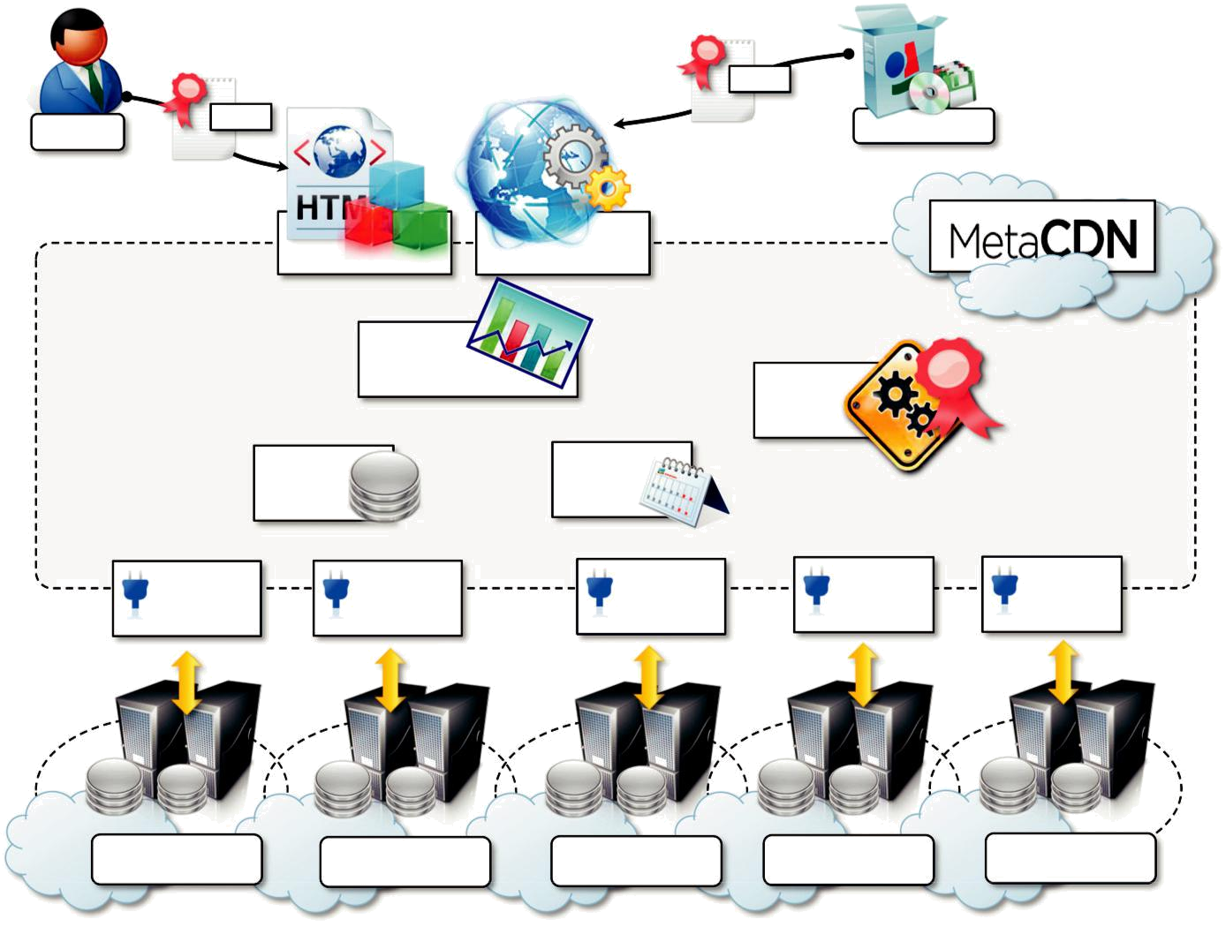
 |  |  | SLA
SLA |  |  | Applications
Users |  |  | Applications
 |  | Web
 | Web Portal | Service Access
 | MetaCDN
 | Load Redirector |  | MetaCDN
 |  |  | Manager
 | MetaCDN | MetaCDN
 | Database | Allocator
Nirvanix | Coral | Azure | S3 | XYZ
Connector | Connector | Connector | Connector | Connector

Nirvanix Coral CDN Windows Azure Amazon S3 XYZ

FIGURE 11.13

MetaCDN architecture.

clouds are managed by means of connectors, which abstract away the different interfaces exposed by the providers and present a uniform interface within the MetaCDN system.

As discussed, the core value of MetaCDN resides in the software overlay that enables the uniform use of heterogeneous storage clouds as a single, large, distributed content delivery network. The advantage is not only given by providing a CDN service at accessible costs but also in enrich-ing the original service offering of existing cloud services with additional functionalities, thus creating a new and more sophisticated service that is of interest to a new market sector.

SpotCloud

SpotCloud has already been introduced as an example of a virtual marketplace. By acting as an intermediary for trading compute and storage between consumers and service providers, it provides the two parties with added value. For service consumers, it acts as a market directory where they can browse and compare different IaaS service offerings and select the most appropriate solution for them. For service providers it constitutes an opportunity for advertising their offerings. In addi-tion, it allows users with available computing capacity to easily turn themselves into service provi-ders by deploying the runtime environment required by SpotCloud on their infrastructure (see Figure 11.14).

SpotCloud is not only an enabler for IaaS providers and resellers, but its intermediary role also includes a complete bookkeeping of the transactions associated with the use of resources. Users deposit credit on their SpotCloud account and capacity sellers are paid following the usual pay-per-use model. SpotCloud retains a percentage of the amount billed to the user. Moreover, by leveraging a uniform runtime environment and virtual machine management layer, it provides users with a vendor lock-in-free solution, which might be strategic for specific applications.

The two previously presented examples give an idea of how different in nature third-party ser-vices can be: MetaCDN provides end users with a different service from the simple cloud storage offerings; SpotCloud does not change the type of service that is finally offered to end users, but it enriches it with additional features that result in more effective use of it. These are just two examples of the market segment that is now developing as a result of the consolidation of cloud computing as an approach to a more intelligent use of IT resources.

